Alternative Energy as a Mean for Reducing the Monopoly of “Gazprom” in Armenia
By
Arman Gasparyan, MA

Contributors: Alexandr Grigoryan, Perchuhy Kazhoyan, Ani Aghoyan, Lilly Minasyan, Nune Sakapetoyan, Karapet Hovsepyan

Contents
Introduction 3
Chapter 1: Market Structure of Energy Resources 4
Chapter 2: Alternative (Renewable) Energy in Armenia: Current State and Future Prospects 8
Discussion: Energy-Based Power of Russia 15
Conclusion 17
Bibliography 18

Introduction

This paper touches upon the problem of natural gas tariffs set by “Gazprom” OJSC for foreign market. Within the framework of this paper two substantial cases will be discussed. Its cornerstone is the natural gas tariff for Armenia, while the problem in two other countries which are somewhat comparable to Armenia regarding their condition and are in a similar economic environment, namely Bulgaria and Romania, will be presented to facilitate the discussion of the Armenian part. Discussion of the two Eastern European states is also essential in that it will assist in finding alternatives for the Armenian energy sector, which would then become less dependent on supply of natural gas from the Russian side. Romania, among other states, was identified, because this state, like Armenia, receives Russian gas through the territory of one transit state (the Ukraine versus Georgia). Still, being a natural gas producer herself, Romania’s dependence on Russian gas supplies is more or less counter-balanced. For that reason, Bulgaria was selected as a natural gas receiver through the territory of Romania, which is roughly in a similar condition. It is argued that during the last decade Gazprom’s supply of natural gas to Armenia has become an efficient lever for the Russian Federation to preserve the rather asymmetric dependency of the former. The analysis of natural gas supply by Gazprom has become of substantial importance for two main reasons. First of all, during the last years Gazprom has demonstrated the characteristics of an unreliable trade partner, constantly changing the price for natural gas supply, which was often, as it will be demonstrated below, independent of external factors. In order to analyze Gazprom’s monopoly power in these three states, Lerner Index was employed.
Further discussion will demonstrate whether this is a natural monopoly, as gas is a natural commodity, or an excessive monopoly, i.e. the monopoly power is used for excessive gains. The second reason is that there is need for competition in the market, which would effectively keep the prices low and. Hence we will discuss the situation of alternative/renewable energy market and the market potential to become a serious alternative for natural gas, by presenting market potential estimates and demonstrating personal and social profits, provided by one of the companies, operating in this market. Case-specific scenarios will be presented, paying particular attention to Armenian participation in Eurasian customs union vis-à-vis signing an association agreement with the EU. The main findings will be summed up in the discussion, which will be dedicated to energy-based power of Russia and the circumstances for Armenia.

Chapter 1: Market Structure of Energy Resources

During the last decade, being the main supplier of natural gas to Continental Europe, Gazprom has managed to effectively manipulate with the price of its product. In order to be able to analyze the company’s market power, Lerner Index was employed for the period 2003-2013.
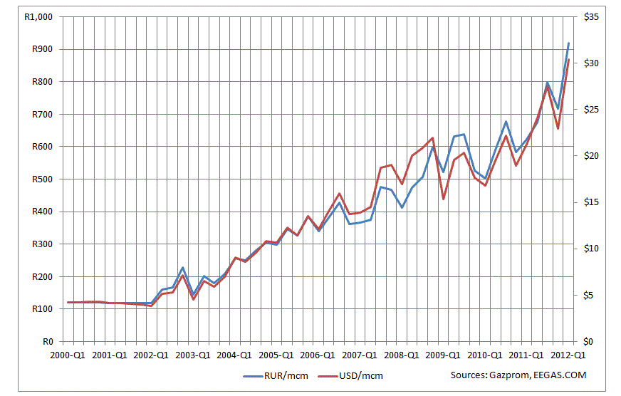
The equation is $L=\frac{P-MC}{P}=\frac{1}{|ε|}$ where P is the market price set by Gazprom and MC is its marginal cost (Elzinga & and Mills, 2010). Under marginal cost, from here on two phenomena are presented, namely (1) the cost of natural gas production, and (2) transportation costs, i.e. actual supply costs. It should be noted that the cost of natural gas production has been constantly changing. From the figure below it could be inferred that the 2000-2013 curve is upward slopping. An overall increase among these years is obvious (from less than $5 to near $30). But, as far as the transportation posts are concerned, the price has been stable. For transportation of 1,000 m³ of gas into Armenia, the price has been almost $24 (Gochitashvili & Gotsiridze, 2002), while for the other two countries it has been $46.6 (Bulgaria) and $45 (Romania) (Fuel-energy Complex of Russia: Research Department, 2009), respectively.
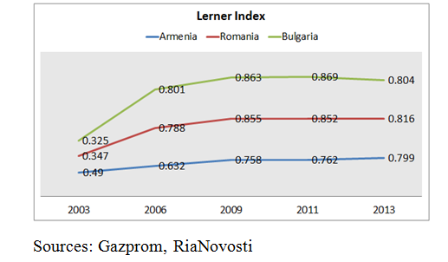
Using the data on natural gas price for these countries set by Gazprom, it is possible to draw a Lerner Index chart for the respectful period. As we can infer from the figure below during the second half of last decade, Gazprom improved its market power considerable. The process was brought into being in all three countries simultaneously. It is also noticeable how the coordinates raised ubiquitously between 2003 and 2006. This phenomenon first and foremost took place because of a considerable increase in supply cost per 1,000 m³: From $55 to $100 in Armenia, from $75 to $318 in Bulgaria and from $75 to $290 in Romania. To put it more bluntly, the price for natural gas increased from 82% to 324% in three years. Another trend that should be considered is that during the resent years the coordinates for Bulgaria and Romania slowly began to drop. This trend is significant if we compare the data for 2009 and 2013. In both states, the coordinates reached 2006 numbers, i.e. before the global financial crisis.
This phenomenon has both logical and counter-intuitive reasons. Firstly, Gazprom does not possess monopoly power in EU market, due to harsh anti-monopoly laws that exist in the European Union (European Commission, 2012). Secondly, the Russian Federation considerably tightened its capabilities and bargaining power after its accession to World Trade Organization (WTO) in 2012 (World Trade Organization, 2013). Since then, it had to liberalize its activities in foreign market, so that not to lose potential and existing clients. Another major reason is that, during the second half of previous decade Romania began utilizing its natural gas resources, which made the country more or less independent of Gazprom supplies. And the last reason why Gazprom started to decrease the price for gas in European market is the possible penetration of a new competitor. In late 2011 significant offshore natural gas resources were discovered in Cyprus (PR Newswire, 2011). It is projected that during the upcoming years Cyprus will become an exporter of natural gas and a major supplier to the Mediterranean region. This would, in effect, cause huge problems to Russia, which has since independence become a ‘resource curse’ state (De Rosa & Iootty, July 2012), as the largest portion of its economy allocates for an export of crude natural resource commodities, mainly oil and natural gas.
In this regard, the counter intuitive finding is that the production costs increased significantly during the aforementioned period, rising from $16.5 in 2006 to 30.43in 2012/2013, i.e. almost twice. As far as the Armenian market for energy is considered, the situation is both more vivid and complicated. The massive gasification of Armenia was launched in 1997, when “ArmRosgazprom” CJSC was established with three shareholders: Gazprom (45% share), Russian “Itera” Group (10% shares) and Armenian Energy Ministry (45% share). In 2006, Gazprom acquired commanding share of ARG. Currently, Gazprom controls 80% of ARG shares, while the remaining 20% are controlled by the Armenian government (ARKA, 2013).
In contrast to European market, where the anti-monopoly policies are on well-established grounds, the Armenian government does not possess any serious tool or counter-arguments against the Russian energy monopoly in Armenia. Gazprom (namely Russia) has efficiently managed to remove any potential predator from the field. For instance, the long-promoted Iran-Armenia gas pipeline's diameter was reduced from initial 1,420 to 700 millimeters, which some experts describe as a result of extensive pressure from Gazprom (Socor, 2007). It is apparent that having been built at the initial diameter, the pipeline would allow Islamic Republic of Iran (IRI) to export its natural gas to European markets, becoming a direct competitor to Russia's natural gas industry.
Recalling the same figure above, one would pay attention to how, the coordinates in Armenian have been rising through years. The background information, which was presented, comes to explain this situation. Being a monopolist in the market, without any visible actor that would counter-balance tis actions, Gazprom has effectively managed to raise the prices and gain extensive profits from its supply of natural gas. Another major point should be presented below. Although there are several companies operating in Russian market of energy resources, the role of exporter of gas from Russia is prescribed to Gazprom.
Although Russian Government currently makes an effort to liberalize the market, it also insists that the introduction of two other companies, “Novatek” and “Rosneft”, to overseas liquefied natural gas (LNG) markets shouldn't hurt Gazprom (Khodyakova, 2013). The Deputy Prime Minister Arkady Dvorkovich, who is in charge of fuel and energy, announced that they (the Government) “want to be certain that we are not creating competition for Gazprom in specific markets (Shipilova, 2013).” This announcement clearly states that Gazprom is not a natural monopoly, because it, exhibiting economies of scale, supplier almost the entire market with the backing of Russian Government at a higher cost than a number of competing firms would. Given the well-known definition of monopoly, one would judge that competition would create a lower price for consumers both domestically and in foreign markets (Steinemann, Apgar, & Brown, 2005).
One more major detail is understandable: Gazprom will not lower its price for natural gas for Armenia in visible future. Meanwhile, the Armenian Government will start losing considerable financial resources while subsidizing a portion of the price for Russian gas supplied to Armenia (Tert.am, 2013). Taking into consideration current scenario, alternative measures should be presented about how to throw off the asymmetric dependency on import of natural gas from Russia.

Chapter 2: Alternative (Renewable) Energy in Armenia: Current State and Future Prospects

The alternative (or renewable) energy has a considerable potential in the world. Still, in Armenia, it should be noted that the energy sector regulation is a complicated process, with a whole bunch of different government agencies involved. The general energy-related issues in Armenia are regulated by the Law on Energy of the Republic of Armenia while specific issues related to RE are regulated by the Law on Energy Saving and Renewable Energy.
The functions of regulation in energy sector were given to the Public Service Regulatory Commission (PSRC) in accordance with the Law on Energy (Danish Energy Management, 2011, p. 26). Each year the Commission presents its operation program for the following year to the National Assembly. The aforementioned program includes all the aspects of energy production: a prediction of consumption of electrical, thermal energy, and natural gas; generation, export, and import of electrical energy; import volumes of natural gas; tariffs for electrical, thermal energy, and natural gas. PSRC also issues a directive each year that specifies feed-in tariffs for diverse energy sources. The Commission has control over providing licenses and establishing tariffs in the energy sector.
Before going to discussing the potential risks and benefits that alternative energy might introduce, one should carefully analyze the current status in the sphere. The table at the end of this chapter shows the prediction for the year 2020 on the volume of RE (renewable energy) usage. There are two main issues worth discussing in this chapter: thermal energy and transportation. With the collapse of the Soviet Union the vast majority of urban centralized heating systems were dismantled.
Approximately one third of the population has installed individual natural gas powered heating systems, fostering the monopoly of Gazprom in this way. This trend has especially enhanced during the last five to seven years. The average cost of these gas powered heating systems for a family is projected to be around $1,500. The price of natural gas in Armenia as of fall 2013 is AMD 156m ($270 per 1,000 m3) (Danish Energy Management, 2011, p. 13).
One of the most complicated problems connected with thermal energy is that most of the multifamily buildings were built using reinforced concrete panels without thermal insulation. What comes to modern buildings is that the construction boom in Armenia has been usually involving modern engineering techniques, which resulted in the introduction of energy efficiency measures, e.g. proper insulation, centralized heating and cooling, as well as double-glazed windows and so forth. Nevertheless, the present installed solar water heating capacity is no more than 250 kW and the quantity of buildings constructed so that to employ solar architecture procedures is very low (Ibid, p. 14).
The major changes in transportation are related mostly to the slow but steady increase in living standards in Armenia and the increase of the country’s GDP which has resulted in an increase of the of the number of privately owned cars. The annual increase rate has been approximately 9% since 2009. At the same time increases in the use of natural gas, an alternative to gasoline has in turn increased the amount of natural gas powered vehicles to more than 40%. This trend has, however, leveled off. Converting an average car to operate with natural gas, costs approximately $1,400, reducing the cost of fuel by half (Ibid, p. 14). Presently there are virtually no hybrid or electric vehicles in Armenia and there is no infrastructure to support electrical cars. Nevertheless, the government has begun to take some measures on that side. One of the most crucial issues is the absence of high quality roads. If the pressing need for such roads to replace existing ones was met, this would subsequently provide a possibility for fuel economy. Currently gasoline costs AMD 490/liter ($1.2/liter) and LPG AMD 160/KG ($0.45/KG) on the Armenian market.
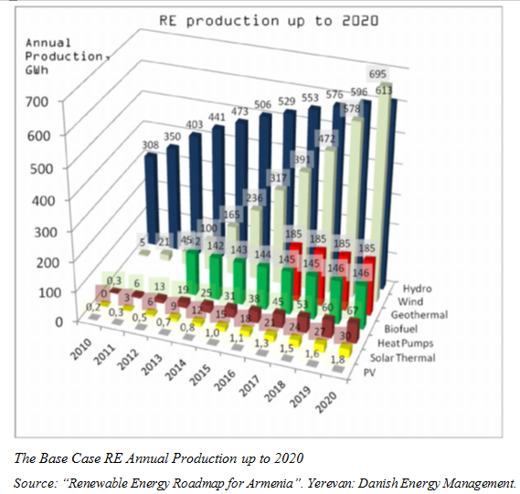
Natural gas, which is essential for the operation of a substantial share of all three energy sectors (electricity, thermal energy, and transportation), is distributed through the monopoly gas company “ArmRosGazprom” of which the Russian company Gazprom owns 80%. In 2010 Armenia spent $224 million for different types of imported liquid fuels (gasoline, diesel and jet fuel, etc.), and $244 million for natural gas (Ibid, p. 14).
Renewable energy has both impacts and benefits that are important for current research. First, let’s discuss these impacts. The main potential impacts of Small Hydro Power Plant (SHPP) projects could be impacts to migrating fish stock if proper fish bypasses are not installed or proper precautionary measures are not implemented to avoid fish being sucked into the turbines (Hambarian, 2012). The possibility of an adverse impact to wildlife if the required minimum water flow is not maintained in the river downstream of the plant also exists and should be considered.
The main impacts resulting from the operation of wind farms are low frequency noise and visual disturbance of the landscape. There is also a possibility of birds colliding with turbine edges; hence, avoiding bird migration pathways for wind turbine farmhouses would lessen this impact.
Bio-fuel production results in virtually no net carbon emissions during a complete life cycle if forests are not demolished to make land available for establishing feedstock.
Even though gasoline that is mixed with bio-ethanol has less CO₂, the blend produces higher nitrogen oxide than gasoline, which is the main component of air pollution that causes smog. Depending on the feedstock, the waste byproducts could be useful as fertilizer, fuel for functioning processing plants, or become waste (Ibid).
Possible impacts from PV panels and solar water heaters could be the visual impact of reflected light. Burning fire wood crates air emissions and small particle matters that could be harmful to human health and there could be an impact to the ecosystem due to the unsustainable rates of harvesting biomass. There are no significant environmental impacts from the operation of heat pumps. The case with PV panels will be thoroughly discussed below.
Now let’s consider to potential benefits. RETs (Renewable Energy Technologies) will keep “hard currency” in Armenia, while also creating significant benefits through economic development. RETs create jobs using local resources in the form of a new, "green," high-tech industry with an important export potential. They also expand work indirectly in local support industries, such as banks and construction firms (Danish Energy Management, 2011, p. 16).
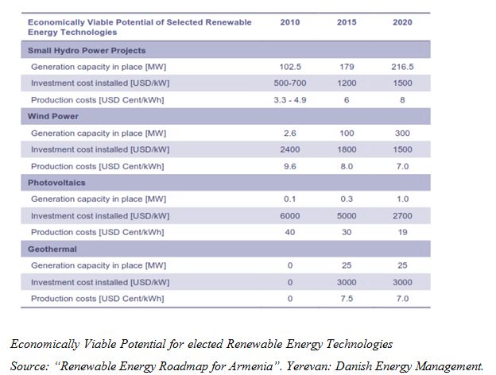
Biomass production is fairly labor intensive, which is one of the main reasons it is somewhat more costly than fossil fuels. The process of growing, harvesting, and transporting biomass fuels requires local labor, as does maintaining the equipment, which contribute to the high cost of bio fuel. However, this means that jobs will be formed in areas with a depressed agricultural economy.
Taking into consideration the RE growth rate in the world, Armenia has the potential to become an exporter of certain RETs if they are developed and improved in Armenia. Manufacturing goods for export will in turn encourage job creation. The next table provides the economic potential for several RETs.
It should be noted that RETs have huge potential not only in Armenia but also worldwide. However, our neighbors’ potential is weak. Georgia neither possesses significant resources, nor has special legislative acts to regulate the use of renewable energy sources. Iran has an abundant supply of fossil fuel resources, which tends to depress the pursuit of alternative renewable energy sources. The same could be said about Azerbaijan. The situation is even more dramatic in Turkey, where renewable energy makes up only 0.2 % of electricity production (Hambarian, 2012). Therefore, Armenia could and should become the regional leader for renewable energy production.
Now let’s proceed to PV industry. The photovoltaic (PV) renewable energy industry is a reliable and proven technology for the production of ‘clean’, eco-friendly energy for over three decades. The photovoltaic industry has considerable demand and potential and is growing worldwide at fast rates (Danish Energy Management A/S, SolarEn LLC).
What regards Armenia, it has some experience in PV technologies and also has deposits of raw materials needed for developing solar energy. Armenia also has some existing infrastructure and skilled experts and numerous experienced institutions. Taking this into consideration Armenia can become a growing power in the development of the PV industry. However there are also some obstacles that hamper the process. In the following chapter the barriers for local PV market development in Armenia will be presented, in addition to recommendations to overcome these barriers.
One of major factors that make Armenia competitive in PV technologies development is the existence of a wide variety of raw materials from various sources throughout the entire country. Moreover, Armenia’s local market potential for solar energy production is supported by the favorable geographic conditions. Armenia is 1,800m above sea level and has a continental climate with hot summers and cold winters, where there are 2500 sunny hours per year and where the average annual solar radiation on horizontal surface is about 1720 kWh/m, whereas the average for Europe is only about 1000 kWh/m (Danish Energy Management A/S, SolarEn LLC). Despite the observable advantages and the vital potential in solar energy production, Armenia does not have a significant amount of projects being implemented in this sector. This is due to many factors which will be discussed below.
Developing the solar energy market in Armenia is challenging, but at the same time it creates great opportunities for Armenia not only it’s local market but also to expand its export markets of PV development. The advantages are evident, however the weaknesses are significant. Some of the weaknesses of developing the PV industry in Armenia consist in the limited market opportunities; the high initial costs for entering the market, high operational and functional costs; in addition to the already highly developed and state supported power infrastructure of the country.
One of the most urging threats in what regards the development of renewable energy sector in Armenia is that there are low energy prices in the country due to the already existing energy plants and excess of produced power from those plants, as well as the government subsidized natural gas prices (Hambarian, 2012). This obstacle may be directly tied to the lack of political will that exists in the country to successfully quantify externalities and the benefits from energy independence. The lack of political will in addition to the lobbying power that the well-established conventional energy groups and influential individuals have creates the most difficult barriers that hamper the alternative energy sector development.
The energy infrastructure that already exists in Armenia should support the development of a more energy-intensive economy in the future. This constitutes as a challenges to the country’s energy sector since Armenia is a country which lacks domestic fossil fuel resources, and therefore is dependent from imported fuel from neighboring countries – specifically Russia (Hambarian, 2012). This leads to having non-diversified supplies of energy resources, and it reinforces the lack of investments aimed at upgrading this sector. The RA government legislation urges that domestic energy sources be developed, specifically renewable energy sources. Many government programs have been implemented to boost solar energy generation capacity in the country. An example of this is when in June 2005 the government of Armenia adopted the Energy Sector Development Strategy, which mainly puts the emphasis on diversification of fuel supply and generation.
Despite the fact that alternative energy production is theoretically encouraged through government policies, legislations and regulations, none of the proposed initiatives and legislations has been enacted. In addition to this, no well-defined mechanisms have been created in the country designed to provide incentives for the development of the renewable energy sector. As mentioned above, there is also lack of experience and opportunities from local banks in Armenia, which do not provide favorable circumstances for local and international investors. Also, there is lack of experience of foreign commercial banks in Armenia, and a general lack of favorable regulative and incentives structures (Hambarian, 2012). Moreover, there is a lack of state support for developing the alternative energy sector in the country. Although the ‘Energy Saving and Renewable Energy Law of Armenia’ emphasizes the importance of renewable energy development in Armenia there are no incentive packages instituted to promote renewables in Armenia.
Taking this into account, it should also be mentioned that the few companies operating in the field experience significant pressure and difficulties from beyond. To find more information about the current activities done in the renewables market in Armenia, an interview was done with one of companies operating in the market, “Ecosystems” OJSC. As it was inferred from an interview, the Armenian market is quite promising due to the massive number of sunny hours in the country.
Moreover, the new technology makes possible to utilize the solar panels not only during daily hours, but 24 hours a day, with little deterioration of quality. This is partially because of the fact that modern panels operate not on solar light, but on solar rays, which are able to penetrate into Earth though clouds, smog, foggy and snowy weather. The only considerable problem for modern solar turbines might be cumulonimbus clouds, which ingest 60-70% of solar rays (Hovsepyan, 2013). Current panels cost approximately $3,500 per household (min. $1,500, max. $10,000, depending on number of residents, space covered, etc.) and reduce the nature gas usage by 70% (data available upon request). The average period of self-sufficiency is 3-4 years. Another major benefit of solar panels is that they are, compared to natural gas or oil, environment-friendly and do not cause any damage neither to the main consumers, nor to the society. At the same time it was recalled that after the accession into the Customs Union, the market of alternative energy will face significant problems. It is largely because of what Armenia will have to increase the customs clearance tariffs set for non-CIS member-states by almost 30% (this information was provided by an expert from RA State Revenue Committee who decided to be anonymous). It is known that various parts of solar panels are not available in Armenia and are currently imported either from EU or from China. Under the Customs Union regulatory framework the Armenian companies will have to import these pieces shall be imported from Belarus, the only supplier of alternative energy technologies among post-Soviet states. However the quality of these components is significantly lower than that of European or Chinese products. In other words, accession into the Customs Union of Belarus, Kazakhstan, and Russia would significantly worsen the prospects of developing alternative energy in Armenia.

Discussion: Energy-Based Power of Russia

As it was already mentioned in previous chapters, the Russian Federation has managed to accumulate considerable political power in Armenia and gain significant achievements in the country via Gazprom. The issue of natural gas supply has become a magical trump card in the hands of Russian high-level officials when dealing with their Armenian counterparts.
One of the main and most recent achievements was, not of great surprise, the September 3rd announcement by the President of Republic of Armenia Serzh Sargsyan to join the Russian-led Customs Union of Belarus, Kazakhstan, and Russia (euobserver.com, 2013) instead of signing an Association Agreement with the European Union, the main economic partner of the country (DG Trade, 2013). This agreement, which does not promise Armenia vivid economic profits and had a shocking impact on Armenian political and economic elite, is likely to be a result of pressures from the Russian side.
The two main tools of pressuring Armenia have so far been security (namely, the Nagorno-Karabakh issue and border security) and gas supply. These tools have enabled Russia to intervene in Armenian policies both on international and on domestic levels. It is proposed that gradual development of alternative energy in Armenia would dismantle the Russian influence and become the first step towards liberating the county’s political life. Nevertheless, the new customs clearance tariffs set by the Customs Union question the likelihood of this scenario.
It should be noted that there is a visible lack of alternatives, as far as security is concerned, because no other actor in the region can become the guarantor of security in the region at the moment. The European Union does not possess any significant military capacity, while its own security is preserved by NATO forces. Although the Armenian armed forces participate in annual trainings organized by NATO, the country’s elite units are trained in Greece (a NATO member-state) the possibility of joining NATO is quite low, first and foremost because the member-state closest to Armenia is Turkey, which, due to certain circumstances, cannot become the guarantor of security and stability in the region. Thus, there are no visible alternatives to Russian-led CSTO at the moment.

Conclusion

Within the framework of this paper several key issues were discussed and significant problems were identified. First of all, it was demonstrated that Gazprom has accumulated extensive monopolistic power in Armenia, unlike the EU states, where harsh anti-monopolistic laws exist. While other states managed to throw off the dependency on Russian energy resources, the situation in Armenia worsened through time. Up to now, the Russian Federation has managed to gain advantages in Armenia, which are of pure political value. This paper also discussed the possibility of reducing the monopoly of Gazprom in Armenia via development of alternative energy.
Although several steps have already been taken to analyze this market’s profitability, the prospects are still hazy. There are currently a few companies operating in the field; however Gazprom manages to effectively draw them out of big markets and most profitable customers. Signing an Association Agreement with the EU would noticeably strengthen these companies’ position in the market, as compared to Gazprom.
Nevertheless, a different scenario was followed. As a result, Russia is thought to increase its instruments of pressurizing the Armenian Government. All things considered, the future of alternative energy is visible in the world and there still is some hope for its development in Armenia, which would be a considerable achievement both for the country and for the region as a whole.

Bibliography
ARKA. (2013, 06 19). Armenian government and Gazprom reach no final decision on arg share. Retrieved from ARKA News Agency: http://arka.am/en/news/economy/armenian_government_and_gazprom_reach_no_final_decision_on_arg_share/
Danish Energy Management. (2011). Renewable Energy Roadmap for Armenia. Yerevan: Armenia Renewable Resources and Energy Efficiency Fund (R2E2).
De Rosa, D., & Iootty, M. (July 2012). Are Natural Resources Cursed? An Investigation of the Dynamic Effects of Resource Dependence on Institutional Quality. The World Bank. Retrieved from http://elibrary.worldbank.org/docserver/download/6151.pdf?expires=1381517456&id=id&accname=guest&checksum=095BA75E0771AAB2716E0020FD2B8801
DG Trade. (2013, 07 05). Armenia: EU Bilateral Trade and Trade with the World. Retrieved from European Commission Web site: http://trade.ec.europa.eu/doclib/docs/2006/september/tradoc_113345.pdf
Elzinga, K. G., & and Mills, D. E. (2010). The Lerner Index of Monopoly Power: Origins and Uses. Charlottesville, VA: University of Virginia, Department of Economics.
euobserver.com. (2013, 09 03). Armenia to join Russia trade bloc, surprises EU. Retrieved from EUobserver.com: http://euobserver.com/foreign/121304
European Commission. (2012, 04 12). Competition and Consumers. Retrieved from European Commission Web site: http://ec.europa.eu/competition/consumers/
Fuel-energy Complex of Russia: Research Department. (2009, 09 30). The Institute of Natural Monopolies Research (IPEM). Retrieved 09 15, 2013, from http://ipem.ru/research/fuel/fuel_works/30.html
Gochitashvili, T., & Gotsiridze, R. (2002). Georgia: Blue Fuel as a Lever of Regional Politics (in Rus.). Sweden: CA&CC Press AB Publishing House.
Hambarian, A. (2012, November 7). Alternative Energy in Armenia. (P. K. Arman Gasparian, & Arman Gasparyan, Perchuhy Kazhoyan, Interviewers) Yerevan.
Hovsepyan, K. (2013, September 21). Alternative Energy in Armenia. (A. Gasparyan, Interviewer)
Khodyakova, Y. (2013, 04 29). Rosneft, Novatek plan to challenge Gazprom's domestic market share. Retrieved from Russia Beyond the Headlines: http://rbth.co.uk/business/2013/04/29/rosneft_novatek_plan_to_challenge_gazproms_domestic_market_share_25589.html
PR Newswire. (2011, 12 28). Noble Energy Announces Significant Natural Gas Discovery Offshore Republic of Cyprus. Retrieved from PR Newswire Web site: http://www.prnewswire.com/news-releases/noble-energy-announces-significant-natural-gas-discovery-offshore-republic-of-cyprus-136305648.html
Shipilova, E. (2013, 05 24). Russia to cancel Gazprom’s liquefied gas export monopoly. Retrieved from Russia Beyond the Headlines: http://rbth.co.uk/business/2013/05/24/russia_to_cancel_gazproms_liquefied_gas_export_monopoly_26335.html
Socor, V. (2007). Iran-Armenia Gas Pipeline: Far More Than Meets the Eye. Eurasia Daily Monitor Volume: 4 Issue: 56. Retrieved from http://www.jamestown.org/single/?no_cache=1&tx_ttnews%5Btt_news%5D=32607#.UlhG1SpXuY0
Steinemann, A. C., Apgar, W. C., & Brown, H. J. (2005). Microeconomics for Public Decisions. Mason, Ohio: Thomson South Western.
Tert.am. (2013, 09 11). Gas price subsidizing issue to be settled soon – Armenia’s energy minister. Retrieved from Tert.am Web site: http://www.tert.am/en/news/2013/09/11/armen-movsisyan/
World Trade Organization. ( 2013). Accession status: Russian Federation. Retrieved from WTO Web site: http://www.wto.org/english/thewto_e/acc_e/a1_russie_e.htm

