Spillovers from Global and Regional Shocks to Armenia

Knarik Ayvazyan and Teresa Dabán



© 2014 International Monetary Fund WP/

IMF Working Paper

MCD

Spillovers from Global Economy into Armenia[1]

Prepared by Knarik Ayvazyan and Teresa Daban

Authorized for distribution by Mark A. Horton

May 2015

|  |
| --- |
| **This Working Paper should not be reported as representing the views of the IMF.**  The views expressed in this Working Paper are those of the author(s) and do not necessarily represent those of the IMF or IMF policy. Working Papers describe research in progress by the author(s) and are published to elicit comments and to further debate. |

Abstract

|  |
| --- |
| Using a structural vector auto-regression (SVAR) model, this paper examines the size, geographical sources, and transmission channels of global and regional shocks to the Armenian economy. Results show that Armenian economic activity is strongly influenced by global demand shocks and changes in oil prices, yet relatively immune to financial volatility. Transmission takes place through the Russian and EU economies and remittances and external borrowing; the role of exports and tourism is low. Russia is key in transforming the potentially negative impact of an increase in oil prices into a positive event, through stronger remittances and exports. Services and construction, which depend significantly on remittances and external borrowing, are the most affected by global and regional shocks. |

JEL Classification Numbers:E6, F240, F47, F41, F430

Keywords: Spillovers; Trade; Business cycles; Transmission channels, Remittances, SVAR

Author’s E-Mail Address: [tdaban@imf.org](mailto:tdaban@imf.org); [knarik.ayvazyan@cba.am](mailto:knarik.ayvazyan@cba.am)

Index

I.Introduction 5

II. Background: Global and Regional Shocks and Transmission Channels to Armenian Economy 6

A.Global and Regional Shocks 6

B.The Main Transmission Channels: Links with Trading Partners 8

III.Estimation and IdentificationTechniques 14

A. The baseline Sructural Vector Auto-Regression Model 14

B. Decomposition of Spillovers By Geographical Areas and Transmission Channels 15

C. Sectoral Analysis 17

D. Data 17

IV. Econometric Results 18

V. Conclusion 23

Annex I: Brief Review of Literature on Spillovers 24

References 26

Figure 1: Real GDP growth (yoy) in Armenia, Key Trading Partners, and the World GDP 7

Figure 2: Commodity prices (2005=100)  7

Figure 3: Oil Price and Ruble/US$ Exchange Rate 7

Figure 4: Armenia’s Remittances and Exchange Rate 8

Figure 5: Armenia: Geographical Structure of External trade 2010-2013 9

Figure 6:Armenia:Structure of External Trade by Type of Products 2010-2013 9

Figure 7: Figure 7: Armenia: Remittance Net Inflows (In million of Armenian drams) 10

Figure 8: Growth Rates (yoy) of Russian Nominal GDP and Armenian Remittances (In percent)  11

Figure 9: Growth Rates (yoy) of Armenian Nominal GDP and Armenian Remittances (In percent)  11

Figure 10: Armenia Capital Inflows In percent of GDP 12

Figure 11: Armenia: FDI Geographical Composition and External Borrowing 13

Figure 12: Armenia: Structure of FDI Stocks and Flows 14

Figure 13: Bayoumi and Swiston approach 16

Figure 14: Cumulative Response of Armenian Real GDP Growth to Structural one S.D. Innovation 19

Figure 15: Decomposition of Spillovers by Main Trading Partners: Cumulative Response of Armenian GDP Growth to a World Demand Shock  20

Figure 16: Decomposition of Spillovers by Transmission Channels: Cumulative Response of Armenian GDP Growth to a World Demand Shock  20

Figure 17: Decomposition of Spillovers by Transmission Channels: Cumulative Response of Sector Growth to a World Demand Shock 22

Table 1: Economy Openness in Selected countries, 2010-2013 6

Table 2: Co-movement of Armenian GDP growth with Selected Countries 6

Table 3: Sizes of one-standard deviation structural shocks to the model 18

# Introduction

As a small open economy, Armenian economy is highly exposed to global developments, either directly or indirectly through the impact that these developments produce in its main trading partners. In addition, Armenia is highly exposed to spillovers from specific shocks that originate in its main trading partners. Despite its relevance, empirical work on global and regional spillovers to the Armenian economy is scant. It mostly focuses on describing stylized facts, especially Armenia’s large exposure to Russia. To help fill the gap, this paper aims at assessing, in an empirical way, the size, geographical sources, and transmission channels of spillovers from external shocks to Armenia. The goal is to identify the relative contribution of different channels such as trade, remittances, tourism and external borrowing and the role played by different geographical areas such as Russia, the EU and the U.S. The paper aims to answer several questions. First, what is the impact of global shocks on the Armenian economy? Second, what are the countries and regional areas through which this impact takes place? Third, what are the main transmission channels? Fourth, what are the economic activities in Armenia that are most impacted?

These are all important questions, given the substantive increase in Armenia’s openness over the past decade. Linkages to Russia and the EU have greatly expanded through trade—especially exports of minerals and metals, tourism, cross-border financing and remittances. Russia and EU are Armenia’s most important trading partners, with Russia being the major source of remittances, FDI, and other financial inflows. As these linkages have strengthened, Armenia’s exposure to global and regional shocks has increased. Recent examples of these shocks are (i) the global financial crisis of 2008-09 and ensuing high volatility in commodity prices, (ii) the geopolitical tensions in Russia and Ukraine, and (iii) the sharp decline in international oil prices in 2014. Information on the size, geographical sources and transmission channels of these external shocks is critical to guide the design of macroeconomic policies that help to limit or offset their impact.

In line with recent studies of shocks and spillovers, this paper uses a structural vector auto-regression (SVAR) model. As shown in the paper, this technique is both powerful and robust in measuring the response of Armenian GDP growth to shocks. However, the identification of the relative contribution of different transmission channels and geographical areas poses challenges in the case of Armenia. These derive from the oil-exporting nature of the Russian economy, the EU’s high dependence on oil imports, and Armenia’s relative low direct exposure to changes in oil prices. Under these conditions, an increase in international oil prices, which would depress economic activity in EU countries, may have a positive impact on Armenia, because of related increases in Russia’s economic activity. In addition, and despite being an energy-importing country, the increase in oil prices may not have a significant negative impact on Armenia’s economy, given the high level of gasification, the use of long-term energy supply agreements with Russia, and the prevalence of non-hydrocarbon energy sources (nuclear, hydroelectric). To overcome these identification difficulties, this paper uses the econometric strategy proposed by Bayoumi and Swiston (2009) and Reinout, Daniel and Joel (2010). This strategy relies on the estimation of a *baseline* SVAR to capture the impact of global GDP growth on Armenian growth, which is augmented one at a time with data on different sectoral and regional factors.

The findings show the strong response of Armenia’s real GDP growth to shocks to global GDP growth and commodity prices, while it remains relatively immune to instability in international financial markets. Impacts are mainly transmitted through the Russian and EU economies and through remittances and external borrowing. The role of exports and tourism remains low. Russia is significantly important in transforming the negative impact of an increase in oil prices into a positive event in Armenia, through stronger Armenian remittances and exports. Services and construction are the two sectors that depend the most on remittances and external borrowing and are the most affected by global and regional shocks.

The paper is organized as follows. Section II provides background on the stylized facts regarding spillovers of global and regional shocks to the Armenian economy and on the main transmission channels. Section III describes the modeling technique. It also presents the sectoral analysis and provides data information. Section IV shows the main econometric results. Section V concludes.

# Global and Regional Shocks and Transmission Channels to the Armenian Economy

## Global and Regional Shocks

Armenia is a small economy with a relatively high degree of openness, especially when compared to countries (Table 1). All key external flow variables, including exports, imports, remittances, and FDI are sizeable in Armenia. This implies that global economic developments affect substantially the Armenian economy, either directly or indirectly through the impact that global developments have on Armenia’s main trading partners.

|  |  |  |  |  |  |
| --- | --- | --- | --- | --- | --- |
| **Table 2: Co-movement of Armenia GDP growth with Selected Countries, 2001q1-2014q11** | | | | | |
| Cross-correlation of GDP yoy growth in period *t* | | | | | |
| and trading partners, world GDP yoy growth in period: | | | | | |
|  | **t-2** | **t-1** | **t** | **t+1** | **t+2** |
| **Russia** | 0.6 | 0.8 | **0.88** | 0.73 | 0.51 |
| **EU** | 0.63 | **0.75** | 0.74 | 0.62 | 0.36 |
| **US** | 0.62 | **0.69** | 0.67 | 0.48 | 0.29 |
| **World** | 0.61 | 0.78 | **0.81** | 0.66 | 0.39 |
| Source: Authors’ calculations. | | | | | |
| **1** Figures in bold denote the highest correlation for each row. | | | | | |

As a result, economic activity in Armenia usually displays strong co-movement with global activity and with the activity of its main trading partners, including Russia, the EU and the U.S. Figure 1 and Table 2 show that the correlation coefficients between annual GDP growth in Armenia and in trading partners is high, and consistent with world shocks having a material influence on Armenia.

**Figure 1: Real GDP growth (yoy) in Armenia, Key Trading Partners, and the World GDP**

Source: Countries’ statistical services and authors’ calculations.

Recent global and regional events have demonstrated Armenia’s sensitivity to external shocks. The global financial crisis of 2008–09 and high volatility of commodity prices during 2008–11 (Figure 2) hit the Armenian economy very hard. From the crisis onset, remittances and capital inflows declined dramatically and the exchange rate depreciated. Purchasing power weakened, which reduced significantly consumption and activity in the construction sector (the main growth driver during the pre-crisis period). Export-oriented industrial sectors, such as mining and metallurgy were also hit hard, reflecting lower prices and weak global demand. As a result, the economy contracted by 14.1 percent in 2009, the second largest contraction of GDP in the world, after Ukraine. The contraction triggered the implementation of supportive macroeconomic policies that led to large increases in the fiscal deficit and public debt and a reduction in international reserves.

Source: IMF.

At the regional level, the recent escalation of tensions between Russia and Ukraine and the sharp decline in international oil prices are also affecting Armenia. Both developments have led to an increase in the uncertainty about Russia’s economy and a substantial downgrading in Russia’s near-term growth forecast. Regional tensions and declining oil prices have led to capital outflows from Russia, a depreciation of the ruble (Figure 3), and less external funding for Russian companies and banks, which, together with significant increases in the policy rate and bond yields, have translated into weaker investment and growth prospects. All neighboring countries have been affected by these developments, and especially the Caucasus and Central Asia (CCA) region, which is also closely integrated with Russia through remittances and trade. In the case of Armenia, the most visible signs so far have been the significant deceleration in remittances and the depreciation that the exchange rate of the dram (Figure 4).

**Figure 4: Armenia’s Remittances and Exchange Rate**

## The Main Transmission Channels: Links with Trading Partners

***Trade***

In terms of the geographical structure, the EU is the main destination of Armenian exports (Figure 5). The EU’s average share in Armenian exports for the period 2010-2013 was 41 percent, quite above the share of Armenia exports to Russia, which accounts for 23 percent of total exports. Germany is the EU country that absorbs the largest part of Armenian exports, accounting for 22.5 percent of the total Armenian exports to the EU. As regards imports, the geographical structure is slightly more diversified, with the EU accounting for 26 percent of total imports and Russia for 18 percent. Nonetheless, when considered altogether, Russia and other post-Soviet republics provide the largest share of Armenian imports, around 31 percent.

**Figure 5: Armenia: Geographical Structure of External Trade 2010-2013**

(a) Exports (b) Imports

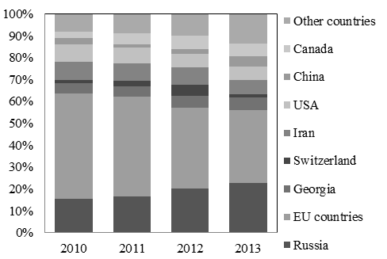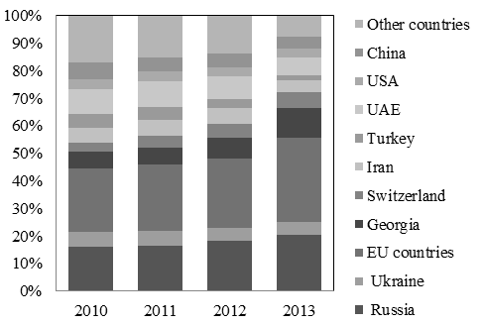

Source: National Statistical Service (NSS) of the Republic of Armenia and authors’ calculations.

As regards product specialization, in the last few years, commodities have increased their shares in Armenian exports and imports (Figure 6). In particular, a significant part of EU exports consists of ores and metals. This implies that fluctuations of commodity prices in international markets could affect the value and volume of exports to the EU, and therefore have an impact on Armenia economic activity. Exports to Russia, however, tend to concentrate on goods with a higher value added and aimed more specifically at the Russian market, suggesting less exposure to changes in commodity prices.

**Figure 6: Armenia: Structure of External Trade by Type of Products 2010-2013**

(a) Exports (b) Imports

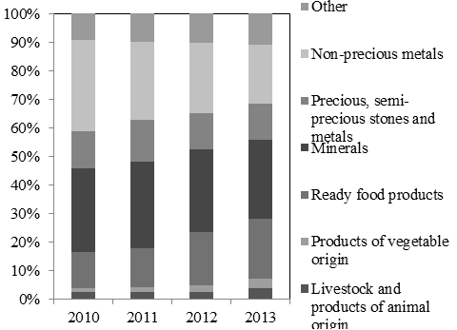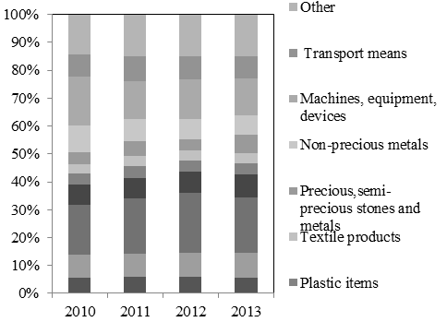

Source: Armenia’s National Statistical Service and author’s calculations.

Source: National Statistical Service (NSS) and authors’ calculations

Imports of energy inputs, including natural gas, oil, petroleum products, and nuclear fuel are especially sizeable in Armenia, accounting for XX of total imports. Russia plays a strategic role on its provision. In fact, Armenia imports 80 percent of its gas from Russia (the remainder is imported from Iran via a gas-for-electricity barter transaction). Furthermore, Armenia has no oil refining capacity, and Russian companies supply most of the petroleum products used in Armenia.

However, despite Armenia’s large energy dependence, the economy exhibits a relative isolation from increases in oil price shocks. This is the result of : (i) high level of gasification, because of the favorable taxation enjoyed by CNG/LNG in comparison to other fuels (e.g. most motor vehicles have switched from gasoline and diesel to gas); (iii) the provision of gas to Armenia has been typically through five-year agreements, with pre-agreed gas prices that are maintained during the period; and (iii) the prevalence of non-hydrocarbon energy sources (nuclear, hydroelectric). This implies that, historically, increases in international oil prices have not translated into negative supply shocks in Armenia.

***Remittances[2]***

Remittances, transferred by Armenia’s large diaspora, are another important transmission channel. They have increased significantly since 2004, especially from Russia (Figure 7), from which at present originates almost 90 percent of total remittances. Although remittances have provided a relatively stable source of external financing, they have exhibited significant volatility, notably with the global downturn in 2008-09. During 2010-13, remittances averaged 15-20 percent of GDP, with a U.S. dollar value that is 22.2 percent higher than total exports, 3.7 times higher than FDI net inflows, and equal to external borrowing. Remittances are equivalent to 43 percent of Armenia’s total imports.

**Figure 7: Armenia: Remittance Net Inflows (In million of Armenian drams)**

Source: Central Bank of Armenia (CBA).

Historically, Armenian remittances have exhibited a growth rate that is highly correlated with Russian nominal GDP growth (Figure 8). This correlation has strengthened even further since the global crisis of 2008-09, reaching 0.95 in the period 2009–2013.

Growth of remittances has also shown a high correlation with Armenian GDP growth (Figure 9).



Source: Armenia’s National Statistical Service.

Source: Federal State Statistics Service of Russia and Central Bank of Armenia

***Capital account***

Another important transmission channel is the capital account. Armenia has an open capital account, critical to financing Armenia’s large external current account deficit. The main items of the capital account are FDI net inflows and external borrowing. Historically, both of them have played an important role in providing funding to Armenian public and private sectors. Portfolio investment has been negligible, except for the recent issuance of Armenia’s debut Eurobond in late 2013 (Figure 10).

**Figure 10: Armenia Capital Inflows In percent of GDP**

Source: Central Bank of Armenia.

FDI inflows have been relatively large (around 5 percent of GDP), but volatile, with a reduction in recent years, following the conclusion of privatization. Inflows have mainly originated from Russian investors, which account for 57 percent of the total FDI stock (Figure 11), followed by France (7 percent), Argentina (6 percent), Germany (4 percent) and Switzerland (3 percent). Although some studies (e.g., Arslanalp and Poghosyan (2014)) identify FDI inflows as an important transmission channel of global and regional shocks, this paper considers that the effect of FDI inflows are structural in nature and with an impact on growth that materialize only in the medium to long term. Therefore, the paper will not include them in the analysis of Armenian economic activity’s sensitivity to shocks.

Instead, this paper would focus on assessing the role of external borrowing, which historically has been played a greater role than FDI as a funding source for the Armenian private and public sectors. In fact, the stock of external debt is relatively large (Figure 11). In Armenia, external borrowing has a long-term, project-based and concessional profile, which could also reduce its links to the business cycle. Most of public debt has a long maturity, with a large concessionality level and focused on capital projects. Most banks’ external borrowing still takes the form of loans with IFIs to support access to finance. However, in practice, it usually increases in response to external shocks, because of larger fiscal deficits and higher recourse to borrowing by households in the face of shocks.

**Figure 11: Armenia: FDI Geographical Composition and External Borrowing**

Source: Armenia’s National Statistical Service and Central Bank of Armenia.

***Banking system***

In many countries, the banking system is an important transmission channel of spillovers from global and regional shocks. The power of the banking sector channel depends on the integration of the banking system into international and regional capital markets, the share of foreign investors in banks’ total assets, and the general soundness of the banking system. In the case of Armenia, the transmission of external shocks through the banking system appears to be limited. First, Armenian banks are largely funded with domestic deposits, with limited exposure to international financial markets. Second, the banking system is not one of the economic sectors that have received significant FDI inflows in recent years (see Figure 12). Moreover, although foreign participation[3] in bank statutory capital is large (74.6 percent at the end of 2013, with Russia as the biggest shareholder, see Figure 12), the operations of the foreign-owned Armenian bank are small compared to the size of their parent banks. Under these circumstances, a withdrawal of liquidity from Armenian subsidiaries is unlikely to provide parent banks with significant support, although there could be withdrawals in case of severe shocks and could lead to a tightening of credit conditions in Armenia. Therefore, this paper will not include the banking channel in the analysis of sensitivity of Armenian economic activity to global and regional shocks.

**Figure 12: Armenia: Structure of FDI Stocks and Flows**

Source: Armenia’s National Statistical Service.

# Estimation and Identification Techniques

## The baseline Structural Vector Auto-regression Model

A frequently used approach to identify macroeconomic shocks is a structural vector auto-regression (SVAR) model[4], which helps capture interconnectedness and endogeneity. SVAR models provide a framework in which all variables can, in principle, be affected by each other helping capture interdependence. The paper’s starting point is a *baseline* SVAR model that estimates the impact of global shocks on Armenian non-agricultural GDP growth. Following Chowla, Quaglietti and Rachel (2014), the *baseline* SVAR includes three types of shocks: (i) *world demand shocks*, which are represented by changes in the growth rate of an indicator of world GDP; (ii*) world supply shocks*, which are given by changes in an indicator of international commodity prices; and (iii) *world financial shocks*, represented by changes in international financial conditions (see Annex I for an overview of relevant literature). The *baseline* SVAR imposes structure on the data, which helps trace shock impacts on Armenian GDP growth.

Following Blanchard and Quah (1989), the variables included in the *baseline* SVAR are ordered as:

.

Where  is the change in world commodity prices indicator,  is the growth rate of an indicator of world economic activity,  is the change in an indicator of international financial conditions, and  is the growth rate in Armenia’s non-agricultural real GDP.

The reduced-form SVAR is:

, 

Whereis a constant and  is the matrix of variables. The reduced-form residuals are mapped into the structural shocks  by the structural matrix :

.

The inverse of the Choleski factor of the variance-covariance matrix identifies structural shocks that are orthogonal to each other, i.e. , whereis the identity matrix. The long-run effects of the structural shocks are given by: . This is equivalent to assuming that the impact of structural shocks in Armenian non-agricultural GDP has zero effects on shocks in the world economy. In other words, under our *baseline* SVAR model the real growth rate of Armenian non-agricultural GDP is affected by world shocks, yet it does not have any influence on world economic activity.

## Decomposition of Spillovers by Geographical Areas and Transmission Channels

To identify the contribution of different geographical areas, most empirical studies based on SVAR models estimate *augmented* SVAR that result from adding to the *baseline* SVAR the growth rates of the GDP of key neighboring regions. A useful example is Adler and Sosa (2012), which analyze the impact of Brazil and Mexico on other Latin American countries. In the case of Armenia, the *augmented* SVAR would include the real GDP growth of main trading partners, such as Russia, the EU and US. The identification of structural parameters in an *augmented SVAR* is relatively straightforward in most regions, such as in Latin America, given limited intra-regional trade and similar sensitivity to moves in international commodity prices (e.g., both Mexico and Brazil benefit from an increase in commodity prices). However, in the case of Armenia, there are several specificities that make it difficult to support the assumption that structural shocks are orthogonal to each other in an *augmented* SVR. These include: (i) strong trade flows between the EU and Russia, and especially strong dependence of Russian economy on growth in the EU; (ii) different impacts of an increase in commodity prices, and especially oil prices, in the EU and in Russia; and (iii) Armenia’s relative isolation from oil price shocks.

To address these identification difficulties, this paper follows Bayoumi and Swiston (2009) approach of identifying the contribution of different geographical areas to the impact of world shocks on Armenian economic activity. Under this approach the *baseline* SVAR is augmented *one at a time* with data on the real GDP growth of EU, Russia and US. The potential contribution of the real GDP growth of a particular geographical area *g* is then calculated as:

.

where *g* = Russia, the EU, and the US. The contribution of each geographical area is estimated as the difference between *r,* which is the impulse response of Armenian non-agriculture GDP growth to a change in world economic activity under the *baseline* SVAR, and *rg* , which is the impulse response of Armenian non-agriculture GDP growth to world GDP growth under the *augmented* SVARthat includes as an exogenous variable the real GDP growth of the geographical area *g.* The idea is that adding the exogenous variable to the SVAR leaves in  the part of the response that is not associated with the growth of the geographical area *g* (Figure 13).

**Figure 13: Bayoumi and Swiston Approach**





*Impact of geographical area g*

Source: Bayoumi and Swiston (2009)Reinout, Daniel and Joel (2010).

This paper also uses the Bayoumi and Swiston (2009) approach to decompose the impact of world shocks on Armenian economic activity into the contribution of different transmission channels, including trade (exports), tourism net revenues, remittances net inflows and net external borrowing. To that end, the *baseline* SVAR will also be *augmented* *one at a time* with data on these transmission channels. As in the case of geographical areas, the potential contribution of the real GDP growth of a particular transmission channel  is then calculated as:

.

where t = trade, tourism, remittances, and external borrowing. The contribution of each transmission channel is estimated as the difference between *r,* which is the impulse response of Armenia non-agriculture GDP growth to a change in world economic activity under the *baseline* SVAR, and *rt,* which is the impulse response of Armenia non-agriculture GDP growth to world GDP growth under the *augmented* SVARthat includes as an exogenous variable the time series of the transmission channel *t.*

The Bayoumi and Swistom (2009) approach has some caveats. It does not exclude the existence of other relevant geographical areas or transmission channels. In addition, it does not account for the potential *collinearity* among the different geographical areas and transmission channels. This approach also implies that the sources of spillovers and are not necessarily required to sum up to the impulse response *r*. However, it is a useful technique to gauge the relative importance of major transmission channels and the impact of different geographical areas as part of the impact of global shocks. In other words, it should not be interpreted as a precise decomposition of the impulse response under the *baseline* SVAR.

## Sectoral Analysis

This paper also aims to identify the Armenian economic sectors that are most affected by global and regional spillovers. To that end, the paper estimates three SVAR models, one each for industry, construction and services. These three *sectoral* SVAR models are similar to the *baseline* SVAR estimated for the whole economy. The main difference is that the three *sectoral* *baseline* SVAR include the real GDP growth rates of the three sectors,  (where s= services, construction and industry) To that end, and again using the Bayoumi and Swiston (2009) approach, the paper develops three *sectoral augmented* SVAR models which will include *one at a time* the time series of transmission channels.

## Data

Estimations are conducted using two sets of variables. The dataset contains real GDP (non-agricultural), real value added in services, construction and industry), and balance of payment statistics time series, including exports, tourism net revenues, remittances net inflows, and total net external borrowing (including private and public sectors). The world and regional dataset includes an indicator of world economic activity (computed as the weighted average GDP of Armenia’s trading partners, weighted by their shares in Armenian exports),[5] a world commodity price index (given by the IMF’s crude oil prices index), and an indicator of international financial market conditions (given by the VIX, which measures investor risk aversion). It includes as well real GDP series for the EU, Russia and the U.S. Data are quarterly for 2000Q1 to 2014Q1. Armenian time series have been obtained from Central Bank of Armenia and National Statistical Service of Armenia. World and regional data have been taken from IMF, WB, Federal State Statistics Service of Russian Federation, Bureau of Economic Analysis, and Eurostat.

# Econometric Results

***What is the overall impact of global shocks on Armenian economy?***

|  |  |
| --- | --- |
| **Table 3: Sizes of one-standard deviation structural shocks to the model** | |
|  | |
| **Variable** | **Size** |
|  |  |
| IMF Crude Oil Index | 73.6 basis points |
| World Demand Growth (In percent) | 0.6 percentage point |
| Financial Volatility Index | 27.8 basis points |

To respond to this question, we estimate the *baseline* SVAR model by including in Z four variables: the change in IMF’s crude oil prices index, the growth rate of weighted-average world GDP, the change in the VIX index and the growth rate of Armenia’s real non-agricultural GDP. The estimation includes two lags, which according to Schwarz information criteria is the optimal lag length. Figure 14 shows the impulse response functions (IRFs) of growth of Armenian GDP to a structural one standard deviation shock in the growth of world GDP and changes in both, the international oil prices index and VIX (see Table 3). The IRFs show that Armenia’s real GDP (non-agricultural) growth is affected negatively, although in small magnitude, by changes in risk perception in global financial markets, measured as one-standard deviation in the VIX index (Figure 14, panel 3). This is an expected result given Armenia’s low level of global financial integration. The IRFs also show that Armenia’s real GDP growth (non-agricultural) exhibits a relatively strong and long-lasting response to a positive world demand shock (Figure 14, panel 2), measured as a world demand growth rate that is one-standard deviation, or 0.2 percentage points, higher. Although the initial impact of global demand shocks is small (1 percentage point), its effects accumulate over time. After two years, Armenian’s response to a change in world demand growth is 3.9 percentage points. This implies that if global demand growth were higher by 0.2 percentage points, the growth rate of Armenia’s non-agricultural GDP would be 3.9 percentage points higher on a cumulative basis, spread in 8 quarters (around 0.4-0.5 percentage points per quarter). This reflects the spillovers through trade, remittance, tourism, and FDI, and bank linkages, from stronger (or weaker) growth in the EU and Russia, which are Armenia’s key trading partners and main sources of remittances and FDI.

**Figure 14: Cumulative Response of Armenian Real GDP Growth to one Structural S.D. Innovation**

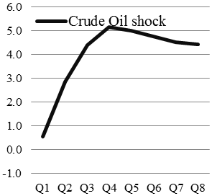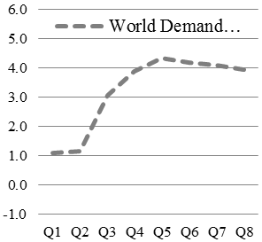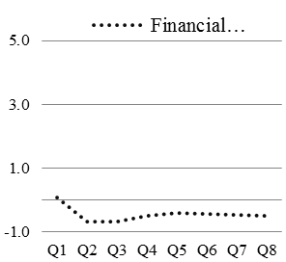

Source: Authors’ estimates.

The IRFs show that an increase in international oil prices tends to produce a positive impact on Armenia’s real GDP growth (non-agricultural). The initial response to an upward oil price shock, measured as a one-standard deviation, is a positive 0.5 percentage points in the first quarter, rising to almost a positive 4.4 percentage points after two years (Figure 14, panel 1). This implies that if international prices changes were higher by 73 percentage points per quarter, the growth rate of Armenia’s non-agricultural GDP would be 4.4 percentage points higher on a cumulative basis spread in 8 quarters (around 0.5-0.6 percentage point per quarter). This strong positive response seems counterintuitive, given Armenia’s high level of energy dependence and lack of oil reserves. Given that Armenia is an oil-importing country, one would expect that an increase in oil prices should have an adverse impact on growth. However, this is more than offset by two factors: (i) the positive impact that an increase in oil prices produces on Russian growth, and therefore on Armenian remittances, exports and external borrowing originating in Russia; and (ii) Armenia’s relative isolation for a direct impact of changes in international oil prices, as explained before.

***What are the geographical areas through which global shocks affect Armenian economy?***

To identify the contribution of different geographical areas to the impact of global shocks, we estimate an *augmented* SVAR by including, *one at time*, the growth rates of Russian, EU and US real GDP. Then we estimate the different contributions, , which are shown in Figure 15. As explained before, the contributions derived from each geographical area should not be interpreted as a precise decomposition of the impulse response under the baseline SVAR, but they can be used to assess their relative importance. Results indicate that in the short-term, (i.e. two quarters) the contributions of EU and Russian growth to Armenia’s GDP growth (non-agricultural) are relatively similar in size. This could be interpreted as follows: when the growth rate of global demand is higher by one-standard deviation, or 0.2 percentage points in one quarter, the total impact of Armenia’s growth rate (non-agriculture) could be split, approximately, into 0.5 percentage point due to the EU and 0.5 percentage point to Russia, with negligible impact from other trading partners. Over a period of 8 quarters, Russia’s contribution to a global demand shocks is considerable larger, accounting for almost 70 percent of spillovers from global demand shocks, while the EU only accounts for 21 percent and the US for only 3 percent. In other words, if global demand growth were higher by 0.2 percentage points per quarter, the 3.9 percentage points impact, cumulative over a period of 8 quarters, on Armenia growth rate of, could be split, on an approximated way, into 2.7 percentage points derived from Russia (0.3 percentage points per quarter) and 0.8 percentage points derived from the EU (0.1 percentage points per quarter).

***What were the transmission channels through which global shocks impact Armenia?***

To identify the contribution of different transmission channels to the impact of a global demand shock on Armenia’s GDP growth, we estimate the *augmented* SVAR including *one at a time* data on trade, tourism, remittances and external borrowing, as exogenous variables in separate SVAR runs.

**Figure 15: Decomposition of Spillovers by Main Trading Partners:**

**Cumulative Response of Armenian GDP Growth to a World Demand Shock**

Source: Authors’ calculations.

The results in Figure 16 show that both remittances and external borrowing account for the largest shares of the total impact of global GDP shocks. The two channels are responsible for the transmission of 28 percent and 31 percent, respectively, of the spillovers from global GDP shocks, while exports and tourism have smaller contributions in the range of 10 percent. This could be interpreted as follows: if global demand growth were higher by 0.2 percentage points per quarter, the growth rate of Armenia’s non-agricultural GDP would be 3.9 percentage points higher on a cumulative basis, spread in 8 quarters (around 0.4-0.5 percentage points per quarter). Remittances would explain 1.1 percentage points out of the 3.9 percentage points for the 8 quarters while external borrowing would explain another 2.1 percentage points, while exports and tourism would account for 0.4 percentage points each. The impact of remittances and external borrowing are particularly important over the longer terms, after one year or beyond.

**Figure 16: Decomposition of Spillovers by Transmission Channels:**

**Cumulative Response of Armenian GDP Growth to a World Demand Shock**

Source: Authors’ calculations.

***What are the Armenian economic activities that are affected the most by global and regional spillovers?***

No all of the Armenian non-agriculture sectors are affected in the same magnitude and time horizon by global shocks. Empirical results, obtained from estimating *sectoral baseline* SVAR models for each non-agricultural sector, show that the one sector that is affected the most is construction (Figure 17), followed by services and then by industry. Moreover, empirical results show that transmission channels operate in different ways depending on economic sectors.

Regarding services, the empirical results show that remittances and external borrowing are the major contributors to the impact of global demand shocks. External borrowing and remittances explain about 54 percent and 21 percent respectively of the impact of global demand shocks in the growth rate of services value added. The contributions of exports and tourisms revenues are relatively small. This could be the result of the expected large influence that remittances and external borrowing would have on households’ disposable income. In particular, external borrowing is likely to support consumer income through higher public deficit and higher bank financing (as part of banks’ external borrowing take the form of loans with IFIs to support access to finance).

As regards construction, results show that remittances are the major contributors to the impact of global shocks. This could be the result of the significant role that remittances played to finance the construction boom that Armenia experienced in the pre-crisis years. Remittances explain almost 30 percent of the impact of global demand shocks in construction activity. External borrowing is also an important contributing factor, accounting for 27 percent of the total impact. Only 5.7 percent of the impact of external demand shocks in construction growth is transmitted through exports of goods and services.

The industry sector shows weak reactions to changes in world GDP. The main contributor factor seems to be external borrowing, which accounts for 25 percent of the total impact, followed by exports and remittances. Export shocks do not seem to play a major role in transmitting the impact of global growth. This could be explained by the dominance of supply shocks over demand shocks in Armenian export-oriented industries, especially mining. The growth of mining output in Armenia, which is one of the driving forces of Armenian exports and industry, seems to depend more on the international prices of metals and minerals than on the growth of world demand.

**Figure 17: Decomposition of Spillovers by Transmission Channels:**

**Cumulative Response of Sector Growth to a World Demand Shock**

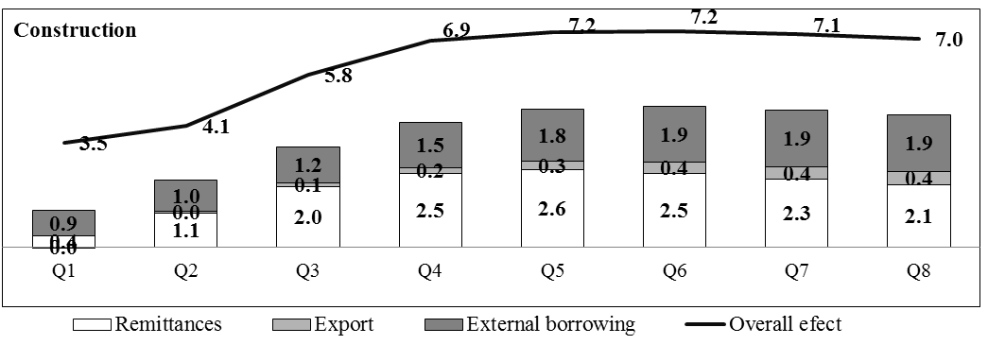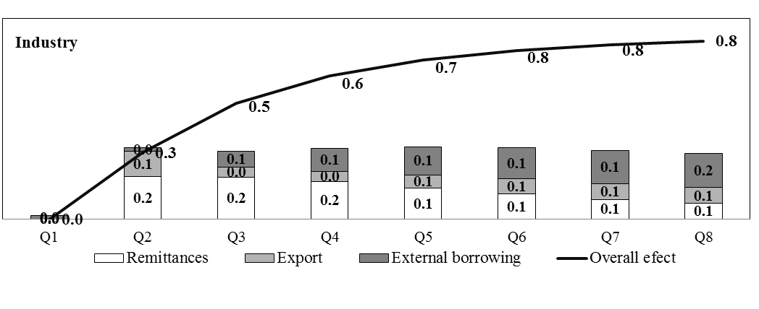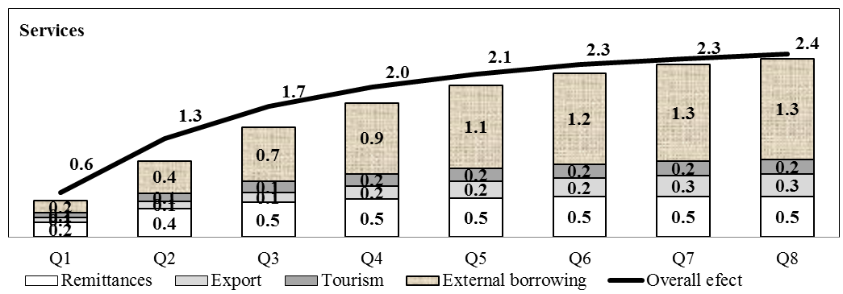

Source: Authors’ calculations.

# CONCLUSION

Using a SVAR model, this paper examines the size, geographical sources and transmission channels of global and regional shocks to Armenian economy. Results show that the impact of global demand shocks is sizeable and long-lasting. The impact is mainly transmitted through the Russian and EU economies, two of the world’s geographical areas with the strongest trade, tourism, remittances and financial linkages with Armenia. These two regions account for 70 and 21 of the total impact respectively. Russia is important in transforming the negative impact of an increase in oil prices into a positive event in Armenia. This is because the negative impact that higher oil prices may have on the Armenian oil bill are more than off-set by the positive effect that the surges usually have on Russian growth rate, and therefore on Armenia’s remittances, exports, financing, and economic growth. Our analysis also shows that remittances and external borrowing are the main transmission channels of spillovers from global shocks to Armenian economy, explaining 28 and 31 percent of total impact respectively, while the role of exports and tourism remains low. Consistently, services and construction, which are the two sectors that depend the most on remittances and external borrowing, are the most affected by global shocks.

Our analysis also provides useful insights on the potential impact of ongoing and expected global and regional developments on the Armenian economy. Some *global developments,* such as the normalization of monetary policies in advanced economies and the ensuing tightening in global financial conditions, would not have a strong *direct* impact on Armenia, given the large share of Armenia’s external debt on concessional terms, the low international integration of Armenian banks, and negligible level of external portfolio investment. A change in international oil prices are not expected to have a direct impact on Armenia economy, given Armenia’s relative high level of gasification and long tradition of medium-term gas price agreements with Russia. However, our paper shows that these developments would affect Armenia *indirectly* via trading partners. For instance, the recent decline in commodity prices (especially oil prices), which is translating into lower growth for Russia, is expected to affect negatively Armenia, via lower remittances and exports. Geopolitical tensions with Ukraine and the ensuing US-EU sanctions on Russia and counter sanctions are deteriorating Russia’s growth prospects and therefore Armenia’s ones. A tightening in global financial conditions could hinder Russia’s access to international funding, and reduce Russia’s willingness to provide bilateral external borrowing to Armenia. A delayed recovery in EU may also hinder its capacity to provide funding to Armenia. Our analysis shows that even a reduce deviation, such as a one-standard reduction, in the growth path of Russia could lead to a huge deterioration in Armenia’s non-agriculture GDP. Therefore, current predictions of a reversal of Russian growth from 3.5 percent to -4 percent in 2015 and a slowdown in the EU from 1.5 percent to 0.5 percent would have a significant negative impact on Armenia’s path growth.

As regards the *right policy response*, the Armenian authorities would need to consider the following options:

*on a pre-emptive basis, before the shock hits*, the authorities should focus on building and preserving macroeconomic buffers, including moderate levels of public deficit and debt, and a relatively high level of international reserves; this would help Armenia to tap external borrowing from donors and preserve current access to market; in addition, the authorities should focus on improving the business climate and improving the country’ openness and connectivity, to attract foreign direct investment and promote export-oriented activities; this could help ensure a higher degree of economic diversification, and, eventually a reduction of the country’s dependence on remittances, especially from Russia;

*in the short-term, once the shocks has hit*, the Armenian authorities’ room for maneuver is limited, yet not negligible; in the context of comfortable buffers, the authorities should be able to implement a moderate fiscal stimulus and monetary easing; at the same time, they could allow for exchange rate flexibility, which could operate as a shock absorber; while using existing reserves buffers to mitigate excessive exchange rate volatility, which could be warranted given Armenia’s high level of dollarization; simultaneously, the authorities should focus on accelerating structural reforms to increase growth and diversify export destinations and products.

*over the medium term, once the effects of the shock have waned,* the authorities should focus their efforts on rebuilding buffers, by adopting a fiscal consolidation strategy and a plan to rebuild the stock of international reserves, while continuing with the implementation of structural reforms.

**Annex I: Brief Review of Literature on Spillovers**

The assessment of economic spillovers from global shocks and across countries is an area of considerable interest. The questions addressed in our paper have been studied by a wide range of authors for different countries.

*Categorization of global shocks*

A categorization of shocks is important in order to identify shocks in a systemic way. It is useful to distinguish between the *source* of shock and the *transmission channels* through which shocks operate. As regards the sources, shocks are usually associated with a combination of circumstances that are difficult to disentangle. Some studies, such as Chowla, Quaglietti and Rachel (2014) have proposed a categorization of global shocks as:

* *World demand shocks***.** These shocks are associated with a rise or a decline in spending and confidence in the global economy. They include changes in the fiscal plans of major countries or geographical areas, as well as changes in the level of confidence of firms and households and their appetite to spend, hire, invest, and borrow.
* *World supply/price shocks.*These shocks originate in the production sector of the global economy and affect the global supply and prices of goods and services. For example, an unexpected fall in the supply of a commodity that is traded globally would likely trigger a rise in its price.
* *World financial shocks.*These occur in the global financial system, such as increased stress in the international banking system or financial markets. They might relate, among other things, to changes in risk premium, driven by investors’ decisions to reassess their perceptions on a certain asset class, including holdings of foreign exchange. Categorization of financial shocks is supported by much of the theoretical literature: several studies have highlighted the importance of financial frictions in driving business cycle fluctuations[6], while others emphasize that financial crises have particularly large effects on output. According to Reinhart and Rogoff (2009), financial crises are associated with larger output losses and slower recoveries than more “conventional” recessions (such as those driven by central banks actively raising interest rates to dampen demand). Hills, Thomas and Dimsdale (2010) argue that the recent UK recession had a defining characteristic that the financial sector was both the source and propagator of the crisis. Given this, it is logical to capture the role of financial shocks separately to more traditional demand and supply shocks.

*Econometric studies on spillovers form global shocks*

A BVAR model presented by Österholm and Zettelmeyer examined the effect of external shocks to output fluctuations in Latin America. They found that 50 to 60 percent of the variation in Latin American GDP growth was accounted for by external shocks. Conditional forecasts for a variety of external scenarios suggested that Latin American growth was robust to moderate declines in commodity prices and U.S. or world growth, but sensitive to more extreme shocks, particularly a combined external slowdown and tightening of world financial conditions.

Bayoumi and Swiston examined linkages across North America by estimating the size of spillovers from the major regions of the world (the U.S., Euro area, Japan, and the rest of the world) to Canada and Mexico, and decomposed the impact of these spillovers into trade, commodity price, and financial market channels. For Canada, a 1 percent shock to U.S. real GDP shifts Canadian real GDP by some 0.75 percentage point in the same direction, with financial spillovers more important than trade in recent decades.

De Bock, Florea, and Toujas-Bernaté examined the economic and financial linkages between Morocco, Tunisia and their European partners using an SVAR. For Tunisia, exports and tourism appeared to be the major transmission channels. In Morocco, exports, remittances and tourism played relatively equal roles.

Adler and Sosa studied the importance of Brazil’s influence on its neighboring economies, documenting trade linkages over the last two decades and quantifying spillover effects in a VAR setting. While trade linkages with Brazil were significant for the Southern Cone countries (Argentina, Bolivia, Chile, Paraguay, and Uruguay), they were very weak for others.

Dabla-Norris, Espinoza, and Jahan investigated linkages between low-income countries (LICs) and a narrow group of “Emerging Market leaders”. The paper employed both VAR methodologies and dynamic panel regressions to estimate spillovers from the EM leaders to LICs. For commodity-exporting LICs in sub-Saharan Africa and the Middle East, terms of trade shocks and demand from the emerging market leaders were the main channels of transmission of foreign shocks.

Finally, Chowla, Quaglietti and Rachel presented model-based estimates that suggested that world shocks have driven around two thirds of the weakness in UK output since 2007.

**REFERENCES**

Adler, G. and Sosa, S. 2012, “Intra-Regional Spillovers in South America: Is Brazil

Systemic after All?,” IMF Working Paper 12/145 (Washington).

Arslanalp, S. and Poghosyan, T., 2014, ‘Foreign investor flows and sovereign bond yields in

advanced economies’, IMF Working Paper No. 14/27.

Bayoumi, T. and A. Swiston, 2009, “Foreign Entanglements; Estimating the Source and Size

of Spillovers Across Industrial Countries,” IMF Staff Papers, Vol. 56(2), pp. 353–83.

Blanchard, O. and D. Quah (1989). “The Dynamic Effects of Aggregate Supply and Demand

Disturbances,” *American Economic Review,* 79, 655-673.

Central Bank of Armenia, 2013, “Financial Stability Report 2013”, Yerevan

<https://www.cba.am/EN/pperiodicals/fin_stab_14_eng.pdf>.

Chowla,S. Quaglietti, L. and Łukasz, R. (2014) “How Have World Shocks Affected the UK

Economy?” [*Bank of England Quarterly Bulletin,* 2014 Q2](http://papers.ssrn.com/sol3/papers.cfm?abstract_id=2464076##).

De Bock, R. Florea, D., and Toujas-Bernaté, J. 2010, “Spillovers from Europe into

Moroccoand Tunisia,” IMF Working Paper 10/238 (Washington).

Era Dabla-Norris, Raphael Espinoza, Sarwat Jahan, 2012, “Spillovers to Low-Income

Countries: Importance of Systemic Emerging Markets,” IMF Working Paper 12/49

(Washington).

Hills, S, Thomas, R and Dimsdale, N (2010), ‘The UK recession in context — what do three

centuries of data tell us?’, *Bank of England Quarterly Bulletin,* Vol. 50, No. 4, pages 277–

91, available at

[www.bankofengland.co.uk/publications/Documents/quarterlybulletin/qb100403.pdf](http://www.bankofengland.co.uk/publications/Documents/quarterlybulletin/qb100403.pdf).

[International Monetary Fund, Republic of Armenia: 2012 Article IV Consultation and Fifth](http://www.imf.org/external/pubs/ft/scr/2013/cr1334.pdf)

[Reviews](http://www.imf.org/external/pubs/ft/scr/2013/cr1334.pdf), Country Report No. 13/34, Washington DC.

Kiyotaki, N and Moore, J (1997), ‘Credit cycles’, *Journal of Political Economy*, Vol. 105,

No. 2, pages 211–48.

Sims, C (1980), ‘Macroeconomics and reality’, *Econometrica*, Vol. 48, No. 1, pages 1–48.

Who’s driving whom?: Analyzing external and intra-regional linkages in the Americas /

Martin Mühleisen, Shaun K. Roache, and Jeromin Zettelmeyer, editors – (Washington,

D.C.)]: International Monetary Fund, 2008.

1. The authors would like to thank the MCD Armenia team and especially Vahram Janvelyan for extensive comments and support on data issues and econometric work. A preliminary version of the paper was presented at the IMF-sponsored seminar hosted by the Central Bank of Armenia on September 27, 2014 in the context of the IMF Article IV consultation mission.
2. This term refers to non-commercial money inflows made by individuals through the banking system.
3. The financial system in Armenia is dominated by a relatively fragmented banking sector with 89.5 percent of assets held by 22 commercial banks. Non-banking financial sector on the other hand is considered to be underdeveloped.
4. Sims (1980), for instance, proposes the use of VAR models to capture the endogeneity of macroeconomic variables.
5. We believe this is the best indicators as it represents the effective weights of Armenia’s exposure to different regions. The EU’s GDP weight in global GDP is only 12 percent while Armenia’s exposure to EU’s through exports is 30 percent.
6. Kiyotaki and Moore (1997) and Bernanke, Gertler and Gilchrist (1998) introduce credit and financial frictions to the analysis of the business cycle.