Incorporating Liquidity into Portfolio Optimization with Mental Accounts Framework

By

Mnatsakan Sharafyan

Submitted to
American University of Armenia
Manoogian Simone College of Business and Economics
In partial fulfillment of the requirements for the degree of Master of Science in Economics

Supervisor: Tigran Hovhannisyan, PhD

Yerevan 2018

ABSTRACT

We embed demand for liquidity in Portfolio Optimization with Mental Accounting (MA) Framework by Das et al (Sanjiv Das April 2010 ). The paper demonstrates that much is changed in mathematical equality between Mental Accounting (MA) and Mean-Variance Optimization (MVO) Frameworks for aggregate portfolio if we restrict access to some asset classes for one of the sub-portfolio and examines MA framework in real-life conditions with enhanced list of investable sub-asset classes. This work will also provide one way to increase efficiency of portfolio optimization and will show how it can be used in daily operations of wealth management firms.

Keywords: Mental Accounting, Portfolio Construction, Liquidity

ACKNOWLEDGEMENTS

I would like to thank Tigran Hovhannisyan, Gayane Barseghyan and Joseph Simonian for guidance and suggestions received throughout the thesis writing process. All remaining errors are mine.

Contents
Introduction 3
Portfolio Construction Models 6
Results 10
Conclusion 12
Glossary 18
References 18

Introduction

Wealth Management firms offer to retail clients services such as the construction of their investment portfolios and management of their savings. Identifying and meeting each customer needs can become a reality thanks to adopting a right approach for construction of their portfolios. The pivot of portfolio construction is its optimization, and many economists have tried to understand what the theoretical model for the optimal portfolio is. This field has been evolved to the series of models which take into account behavioral factors and investment views of individual investors and can find practical application in the financial field.
Theory of Firm and Theory of Consumers are the embodiment of the first attempts of economists in finding economic equilibrium. Both theories are based on maximizing the objective functions, i.e., profit or utility. Nobel Memorial Prize winner Harry Markowitz in his Modern Portfolio Theory (Markowitz 1952) took the equilibrium model, focused on investors rather than manufacturing firms and considered economic agents making a choice under uncertainty. Three main pillars of the theory were (1) Investors' preferences are Mean-Variance utility functions (2) Investors take prices as given and no transaction costs or taxes (3) one-period investment horizon.
The main components of Modern Portfolio theory are the expected return, standard deviations of return and correlation between all pairs. Expected return in this model is computed based on historical return forecast. Markowitz model is maximizing return for a given level of risk, which is measured by standard deviation of returns. As it is clear from the description of Markowitz’s model, there are several disadvantages, i.e., the standard deviation is not taking into account adverse deviations, a unique universal utility function is hard to define, and optimization yields highly concentrated portfolios, which are oversensitive to changes. During past decades Modern Portfolio Theory has been subject to multiple improvements and adjustments to real-world conditions.
One of the successors to Harry Markowitz's Portfolio Theory is an asset allocation model that was developed by Fischer Black and Robert Litterman from Goldman Sachs (Black Sep/Oct 1992). Their model enables investors to combine their unique views regarding the performance of various assets with market equilibrium and incorporate prior knowledge into computing statistical probability by identifying the consensus portfolio and using Bayesian approach. The mathematical model of Black and Litterman help to overcome the problem of unintuitive, highly concentrated portfolios and input-sensitivity. Thus, BLM chooses gross stocks, balances several contradicting views and makes return forecast statistically consistent.
In 2000 two scholars Hersh Shefrin and Meir Statman embedded new trend of Behavioral finance in Portfolio theory and proposed Behavioral Portfolio Theory (Hersh Shefrin 2000). The foundation of BPT is SP/A Theory (Lopes 1999) and Prospect Theory (Kahneman D. 1979), and the main message of the theory is that some investors are irrational and there are always rational arbitrageurs, who accelerate convergence to the efficient market. Their work shows that BPT and MVT have different outcomes regarding efficient portfolios. In BPT framework authors used mental accounting, which is an economic concept established by Nobel Memorial Prize winner Richard Thaler. This notion implies that individuals assign different levels of utility to each asset group, which affects their consumption decisions and other behaviors including risk aversion. Authors divide their work into two parts: BPT-SA (Single Account), where investors integrate their portfolio into one mental account considering covariance of asset classes and BPT-MA (Multiple Accounts), which consists of two aspiration layers and ignores covariance among mental accounts. Instead of choosing portfolios by considering mean and variance, the BPT investors select portfolio by considering expected wealth, desire for security, potential and aspiration levels, probabilities of achieving aspiration level.
BPT-SA is maximizing Expected Wealth E_{h}(W) for fixed Prob[W < A], where W is expected wealth and A is given payoff. Unlike Mean-Variance investors' risk , risk in SP/A is multi-dimensional and described by (1) measure of the strength of fear (2) measure of the strength of hope (3) Aspiration level (4) strength of fear relative to hope (5) strength of desire to reach aspiration level relative to fear and hope. With regard to BPT-MA, most investors combine high aspiration and low aspirations, i.e., they want to avoid poverty but simultaneously want to have a chance to become very rich. Thus, in BPT-MA each mental account of investors has its separate goal they divide joint probability distribution into mental accounts.
Another work by Sanjiv Das, Harry Markowitz, Jonathan Scheid, and Meir Statman is Portfolio Optimization with Mental Accounts (Sanjiv Das April 2010 ), where authors defined new Mental Accounting Framework, which encapsulates attractive features of Markowitz's mean-variance portfolio theory and Shefrin and Statman's Behavioral Portfolio Theory (BPT). While each Mean-Variance investor chooses to consume from among efficient portfolios the one that maximizes utility, individual investors want their portfolios to satisfy goals such as secure retirement, college education for children and being rich enough. It is clear that risk aversion coefficient differs among goals, and the concept of risk implies not reaching the threshold of each particular goal. MA Problem is to maximize the wealth subject to the probability of failing to reach the predefined threshold level of return. Authors demonstrated the mathematical equivalence between mean-variance optimization (MVO), MA and Value at Risk models.
In MA Framework Das et al. (Sanjiv Das April 2010 ) define three mental accounts and available asset universe consisting of three assets, which is quite a small number compared to real-world asset universe. The framework is developing around the example where the aggregate portfolio consists of three sub-portfolios (mental accounts) with 60%, 20%, and 20% fixed weights and each sub-portfolio chooses weights from same three assets to satisfy assigned goal without taking into account investor’s demand for liquidity. It is evident that while constructing portfolios for retail individuals, financial advisors should not ignore investors’ demand for liquidity and need of having part of their portfolios invested in relatively liquid assets.
This paper is designed to apply Mean-Variance Mental Accounting (MVMA) Framework in daily operations of Wealth Management firms and aims to embed the liquidity into MVMA framework and examines it in real-life conditions by having enhanced list of investable sub-asset classes. Here embedment of liquidity implies having one sub-portfolio with only highly liquid assets such as cash and equivalents. The paper demonstrates that much is changed in mathematical equality between MA and MVO for aggregate portfolio if we restrict access to some asset classes for one of the sub-portfolio. The mentioned inequality entails overlooking covariance between assets, which results that the planner will not offer the most efficient portfolio. This work will also provide one way to mitigate mentioned inefficiency and will show how it can be used in wealth management firms’ daily operations.

Portfolio Construction Models

We first present the chronology of portfolio construction theory starting from Markowitz Mean-Variance Optimization and going into Mental Accounting Framework with some enhancements. MVO is a simple model which maximizes the expected return at a given level of risk measured by standard deviation of the returns representing volatility (Markowitz 1952). Following MVO model, the wealth manager will choose portfolio weights w = [w₁,...,w_{n}] for n investable assets, where the assets have an expected return vector μ ∈ R^{n} and a return covariance matrix Σ ∈ R^{n}.
(1) max w´ μ – $\frac{γ}{2}$ w´ Σ w
Subject to w´1=1, where 1= [1,…, 1] ∈ R^{n}
In the above-mentioned expression, constraint represents fully invested wealth and γ is the individual investor’s risk aversion coefficient, which balances the trade-offs in the mean-variance space. Calculating first order condition with respect to weights and solving it for the maximization problem (1) with Lagrange method yields:
(2) $w=\frac{1}{γ}$ Σ⁻¹ [μ – ($\frac{1^{'}Σ^{-1} μ-γ}{1^{'} Σ^{-1} 1}$) 1] ∈ R^{n}
As expression shows, the weights of a portfolio are heavily dependent on the risk aversion coefficient $γ$, which is widely known in Wealth Management firms as a risk tolerance level for individual investors. Das et al. in the MA framework introduced the sub-portfolio notion, when an individual investor can choose separate mental accounts with different goals and assign different “implied” risk tolerance levels. In MA framework, the equation (2) was used for each sub-portfolio instead of using it for the aggregate portfolio. Authors assumed that investors could easily define risk tolerance by stating the threshold levels for each goal and the maximum probabilities of failing to reach them compared to telling risk aversion coefficient. If investor advise the threshold level (H) and the maximum probability of the portfolio failure (α) in terms of reaching predefined portfolio return r (p) the advisor can offer well-fitted portfolio. Analytically, this can be expressed as Prob[r(p) ≤ H] ≤ α, which is same as H ≤ w´ μ + Φ (α) [w´ Σ w]^{1/2}, where Φ (.) is cumulative standard normal distribution function.
Thus, if one wants to compute the weights of assets of specific sub-portfolio, he can solve the following equation.
(3) H = w (γ) ´ μ + Φ⁻¹ (α) [w(γ)´Σ w(γ)]^{1/2} ,
Where w (γ) = $\frac{1}{γ}$Σ⁻¹[μ – ($\frac{1^{'}Σ μ-γ}{1^{'}Σ1}$) 1]. This means that wealth manager can indirectly compute “implied” risk aversion coefficient (γ) and derive optimal asset allocation for sub-portfolio mapped to a specific goal for the investor, who provides information for H and α.
For each given set of asset data, there are feasible combinations of threshold levels (H), probabilities of failing to reach them (α), and expected returns. To find whether the problem has a feasible solution is to maximize the value of the right-hand side of equation (4) and check if it is greater than H stated by the investor.
(4) max Q = w (γ) ´ μ + Φ⁻¹ (α) [w(γ)´Σ w(γ)]^{1/2},
Subject to w´1=1
In our work, 11 sub-asset classes each with 14 observations have been collected for portfolio construction to have more real-life conditions (See the Appendix 1 for information on data). The sub-asset classes can be grouped into four main asset classes, i.e., equities, bonds, real estate, cash and equivalents. The Prob[r (p) ≤ H] ≤ α equation was served as a base for the construction of the whole model. The paper goes through following simple steps: defining the goals and expectations for each sub-portfolio, setting thresholds (H) and probability (α) of not meeting it. With this aim, we consider three mental accounts for the investor with average needs assigning to each mental account a specific goal.
The first sub-portfolio is for safe retirement and aims to provide investor sound belief for financially stable future. By dedicating a tangible share of current net worth to this sub-portfolio, an investor seeks to ensure definite amount of benefit after retirement. Investors target moderate figures for this sub-portfolio returns and manageable level of risk by setting the threshold level -10% and the probability of failing to achieve 10%. Unlike example provided by Das et al. (April 2010), the second mental account is linked to liquid sub-portfolio, where the goal of the investor is to finance unexpected expenditures and in case of need make emergency encashment. The assets available in this sub-portfolio can be readily converted into cash since they are liquid and easily sold on the market. Considering that retail individuals are planning wealth not only to meet their long-term goals but also short-term needs, the second sub-portfolio will contribute to satisfying of latter goal. Thus, the second portfolio has the constraint of investable asset types as here investor will choose only highly liquid assets irrespective of risk and return trade-off of other ones. This assumption seems quite reasonable and valid in real-world conditions. With this purpose in mind, investor advises to financial planner the threshold level of -5.5% and that the maximum probability of the portfolio failure is 10%. The third mental account is for funds aiming to make the investor richer irrespective of higher risk. Volatile sub-asset classes have large weights in this portfolio and can result in a loss of capital and underperformance relative to expectations. Since here individual is less risk-averse, she sets the minimum threshold of -15% with 20% probability of failure with an expectation to get the more expected return.
Thus, each investor has three mental accounts MA 1, MA 2, and MA 3, where MA 1 and MA 2 choose their asset weights (w) from the same 11 sub-asset classes, whereas MA 2 is limited only to highly liquid assets and choose from two sub-asset classes. The embedment of restriction to less liquid assets for specific sub-portfolio and the enhanced list of available asset universe yields different results compared to the example in MA Framework with three mental accounts each with access to same three assets. Here we are losing some points of efficiency and having mathematical inequality between MVO and MA models due to overlooking covariance between sub-asset classes. To reduce the inefficiency level, we can change the initial weights (Ω) of mental accounts (60/20/20) in the aggregate portfolio and improve it. We have assumed that investor feels more comfortable with defining the range for each mental account instead of stating exact number. For instance, the investor can say that she would like to channel from 50% to 60% of her investable wealth into the first goal (mental account 1), instead of stating exact 60% figure for safer retirement. This assumption seems quite reasonable and helps to offer much more efficient portfolio to investor in terms of higher Sharpe Ratio comparing to initial one.
Analytically, it is
(5) max $\frac{\left[{Ω }_{1}w_{1}´+ {Ω }_{2}w_{2}´+{Ω }_{3}w_{3}´\right]μ}{\left[{Ω }_{1}w_{1}´+ {Ω }_{2}w_{2}´+{Ω }_{3}w_{3}´\right] Σ \left[{Ω }_{1}w_{1}+ {Ω }_{2}w_{2}+{Ω }_{3}w_{3}\right]}$
Subject to a < Ω₁ < b, c < Ω₂ < d, Ω₁ + Ω₂ + Ω₃ = 1, w₁, w₂ and w₃ are given.
Where the objective function is Sharpe ratio of the portfolio and Ω is the weight of corresponding sub-portfolio (mental account) in the aggregate portfolio. Additionally, w₁, w_{2,} and w₃ are assumed to be exogenous variables, which have been derived from equation (3). Considering that we are changing only weights of mental accounts (Ω) instead of the weights of the assets, the equation (5) is for aggregate portfolio and can be solved after asset weights for each mental account are computed. (See Appendix 3 for visualization).

Results

We have drawn parallels between Mean-Variance Optimization and MA Framework in real-life conditions. The results of the simulations show that although depending on given set of assets there can be non-feasible solutions and “implied” risk aversion coefficients, MVMA framework still can be applied to real cases and contribute to Wealth Management firms in identifying and meeting needs of their customers. Additionally, depending on the set of assets there can be cases when risk aversion coefficient is the higher number than it is usually presented in theoretical works.
The results of the model show that by inputting threshold level, and the probability of failing to reach it, financial planner can calculate the most efficient asset weights for specific sub-portfolio and its optimal weight in the aggregate portfolio. By solving equation (4), we have defined a feasible set of threshold levels and probabilities of failing to reach them and chose H and α from that set in line with each goal. During comparing results, we have mainly considered Sharpe Ratio of the aggregate portfolios as an efficiency level and compare figures with each other.
First, we have optimized each sub-portfolio by following MVMA framework without any short selling constraint and like Das et al. (Sanjiv Das April 2010 ) add them with 60/20/20 proportions.
Considering that axis of the MA Framework is assigning different risk tolerance levels to each sub-portfolio, solving the equation (2) and (3) for each mental account yields the risk aversion coefficients for all three sub-portfolios: 3.97, 9.02 and 0.92 respectively. Calculating the risk aversion coefficients are determining part in achieving favorable asset weights for three sub-portfolios. Resulted asset weights are available in Appendix 2.
Second, we have solved canonical MVO problem (1), where the risk-aversion coefficient is equal to 1, to be able to compare MVMA Framework with MVT. The table highlighting differences between MVO and MVMA approaches is in Appendix 3 and reflects main results of the work. It can be clearly observed that optimizing risk-return trade-off by following MVO resulted in the highly concentrated portfolio, where there are nine sub-asset classes which have not been invested. From the perspective of final risk-return trade-off and diversification, MVO has resulted in inferior portfolio comparing with MVMA with 60/20/20 weights of sub-portfolios. This also implied poor figures in the efficiency of the final portfolio, i.e., instead of having 0.2467 adjusted return, the portfolio optimized by MVO had 0.19.
Although the Sharpe ratio and diversification of the resulting portfolios show that MVMA optimization with 60/20/20 was far more efficient than the one derived from simple mean-variance optimization, it is less efficient than several other proportions of sub-portfolio weights. Following the initial assumption that it is easier for investor to state range for each sub-portfolio instead of telling exact percentage, we have considered the case when investor tells to financial planner ranges for each mental account in following way: to channel from 50% to 60% of his wealth into the first goal and less than 25% into the third one. Solving equation (5), we have the aggregate portfolio, which consists of 0.524/0.226/0.25 weights (third column in the table of Appendix 3). By offering the investor the latter weights, we provide the portfolio with Sharpe ratio of 0.2486, which is slightly higher than the initial one. Considering Sharpe Ratio as an efficiency level of the portfolio, the resulted aggregate portfolio has higher efficiency. This simulation proves that we can have higher return for the same level of risk and results to the aggregate portfolio consisting of 52.4% of MA1, 22.6% of MA2 and 25% of MA3.
To sum up, the results of the paper show consistency between theoretical model and its practical application and that wealth managers can improve outcome by adopting MVMA approach instead of MVO. Moreover, asking for a range of each sub-portfolio weights instead of requesting exact figures when investable assets are not the same for all sub-portfolios yields better results than the approach, which was adopted by Das et al. in MA Framework (Sanjiv Das April 2010 ). As a result, the investor would have an aggregate portfolio with outlined client-specific features and higher efficiency level.

Conclusion
We begin with the introduction of basic approaches of portfolio construction and its interaction with behavioral finance. Considering that MA Framework is the last destination of Behavioral Portfolio Theory, it has been applied to real-life conditions with several adjustments and enhancements in our paper. One of the enhancements is the embedment of demand for liquid assets of specific sub-portfolio, which yields different results compared to MA Framework with three mental accounts.
It is worth to mention that although the Mean-Variance Optimization is the underlying model for MA framework, there is no sign of high concentration in the resulted portfolio. This means that without using a mathematical model of Black and Litterman, which designed to overcome the problem of highly concentrated portfolios, MVMA Framework tackles the problem and results in the well-diversified aggregate portfolio.
Summarizing the paper, despite of deficiencies and non-practical aspects of MA Framework, with small adjustments it can be realized in daily operations of Wealth Management firms in terms of assigning separate Risk Tolerance Score to investors’ sub-portfolios. The main novelties of the paper are the enhanced list of sub-asset classes, restriction to less liquid assets for liquid sub-portfolio and suggested more efficient weights for each sub-portfolio. Considering that the biggest financial institutions currently offer variety of wealth products to high net worth individuals (HNWI), this paper can contribute to the improvement of their services and can help to meet customers’ needs.

Appendix 1: Data Summary

Asset Class |  | Sub Asset Class | Chosen Data | Source
Equities : |  | Equity Growth | iShares S&P 500 Growth ETF (IVW) | Yahoo Finance
 |  | Equity Income | Vanguard Equity-Income Inv (VEIPX) | Yahoo Finance
 |  | Small-capitalization stocks | Vanguard Small Cap Index Adm (VSMAX) | Yahoo Finance
 |  | Emerging Market Equity | iShares MSCI Emerging Markets ETF (EEM) | Yahoo Finance
Bonds: |  | Investment Grade Corporate Bond | iShares iBoxx $ Invmt Grade Corp Bd ETF (LQD) | Yahoo Finance
 |  | Short-term Treasury Bond | iShares 1-3 Year Treasury Bond ETF (SHY) | Yahoo Finance
 |  | Long-term Treasury Bond | iShares 20+ Year Treasury Bond ETF (TLT) | Yahoo Finance
 |  | Treasury Inflation Protected Securities | iShares TIPS Bond ETF (TIP) | Yahoo Finance
Real Estate: |  | Real Estate | Vanguard REIT ETF (VNQ) | Yahoo Finance
 |  | Certificate of Deposit | 90-day Rates and Yields: CD for the US | Federal Reserve Bank of St. Louis
Cash and equivalent: |  | U.S. Treasury bonds between one month and one year | iShares Short Treasury Bond ETF (SHV) | Yahoo Finance
TOTAL |  | 11

Appendix 2: Weights of sub-asset classes in each sub-portfolio

 | MA 1 | MA 2 | MA 3
iShares S&P 500 Growth ETF (IVW) | 0.084 | - | 0.026
Vanguard Equity-Income Inv (VEIPX) | 0.001 | - | 0.080
Vanguard Small Cap Index Adm (VSMAX) | -0.060 | - | 0.137
iShares MSCI Emerging Markets ETF (EEM) | -0.047 | - | 0.051
iShares iBoxx $ Invmt Grade Corp Bd ETF (LQD) | 0.327 | - | 0.375
iShares 1-3 Year Treasury Bond ETF (SHY) | 0.841 | - | 0.508
iShares 20+ Year Treasury Bond ETF (TLT) | -0.100 | - | 0.248
iShares TIPS Bond ETF (TIP) | -0.074 | - | -0.364
Vanguard REIT ETF (VNQ) | 0.029 | - | -0.060
iShares Short Treasury Bond ETF (SHV). Year | - | 0.909 | -
90-day Rates and Yields: CD for the US | - | 0.091 | -

Appendix 3: Weights of sub-asset classes in Aggregate Portfolio

 | MVMA Aggregate Portfolio_60/20/20 | Mean-Variance Optimization | MVMA Aggregate Portfolio_0.524 / 0.226 / 0.25
iShares S&P 500 Growth ETF (IVW) | 0.056 | 0.000 | 0.051
Vanguard Equity-Income Inv (VEIPX) | 0.016 | 0.000 | 0.020
Vanguard Small Cap Index Adm (VSMAX) | -0.009 | 0.000 | 0.003
iShares MSCI Emerging Markets ETF (EEM) | -0.018 | 0.000 | -0.012
iShares iBoxx $ Invmt Grade Corp Bd ETF (LQD) | 0.271 | 0.000 | 0.265
iShares 1-3 Year Treasury Bond ETF (SHY) | 0.606 | 0.000 | 0.568
iShares 20+ Year Treasury Bond ETF (TLT) | -0.011 | 0.000 | 0.009
iShares TIPS Bond ETF (TIP) | -0.117 | 0.000 | -0.129
Vanguard REIT ETF (VNQ) | 0.005 | 0.028 | 0.000
iShares Short Treasury Bond ETF (SHV). Year | 0.182 | 0.972 | 0.206
90-day Rates and Yields: CD for the US | 0.018 | 0.000 | 0.020
TOTAL SUM | 1 | 1 | 1
μp | 0.0267 | 0.0090 | 0.0284
σp | 0.1082 | 0.0451 | 0.1140
Sharpe Ratio | 0.2468 | 0.1984 | 0.2486

Appendix 4: Illustration of

Ω₁ Ω₃
MA 2
MA 3
MA1
Ω₂

Appendix 5: Computing Tool

1)
Input Asset data
2)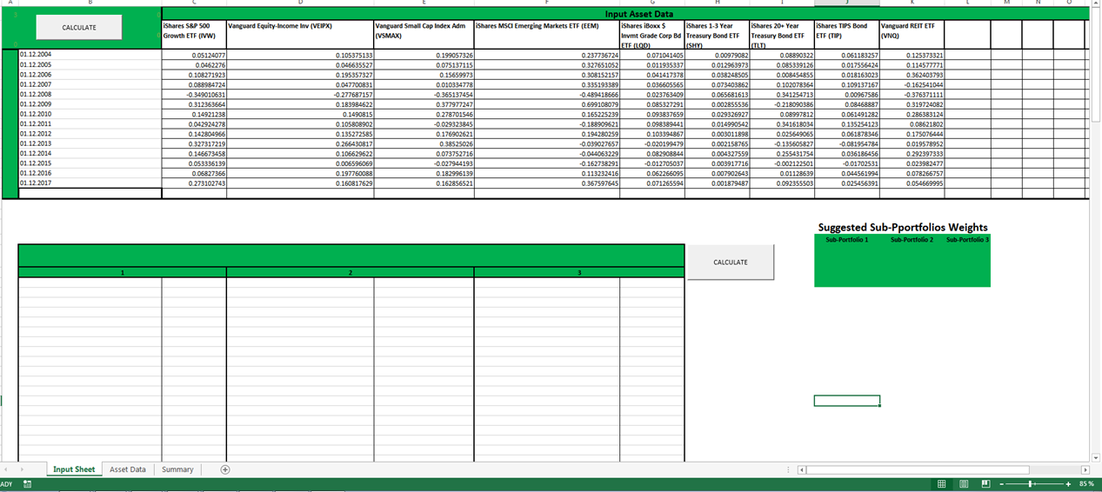
Click CALCULATE

3)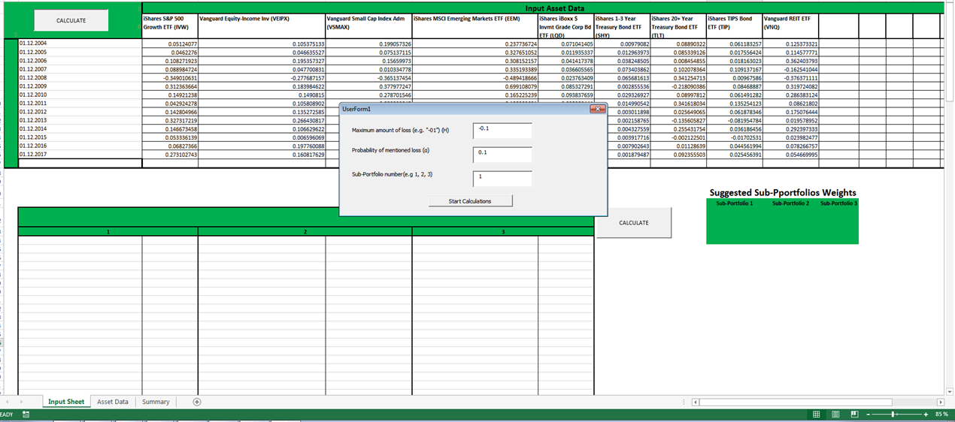 4)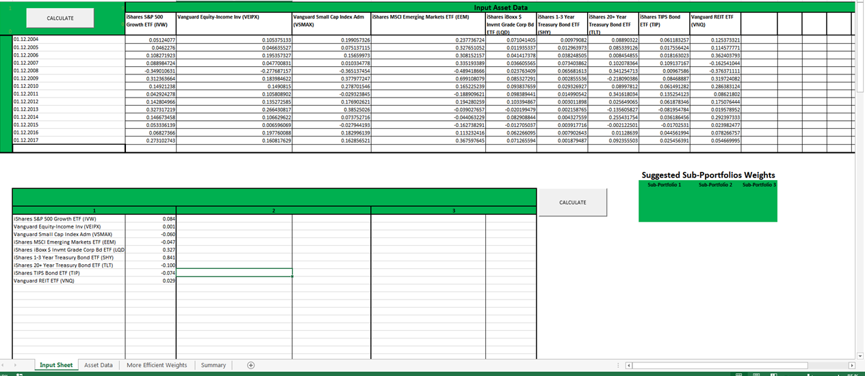 5)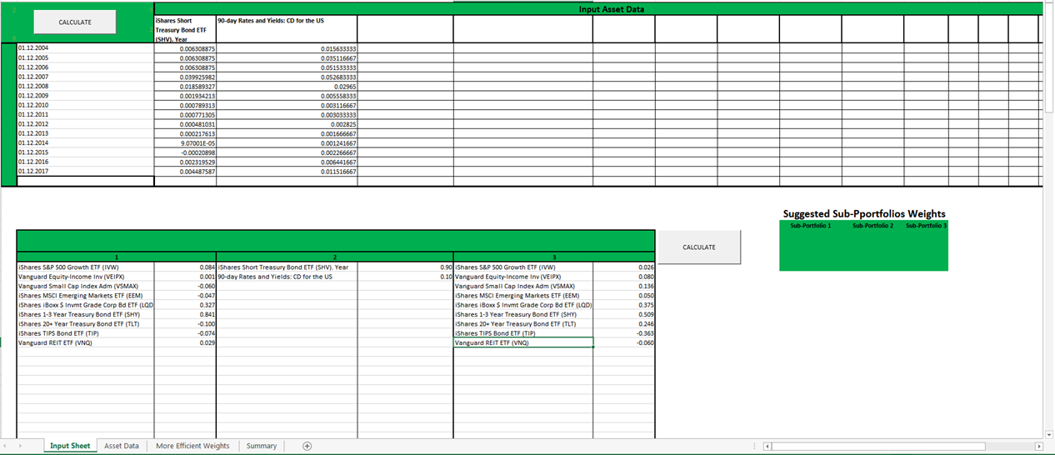6)
Fill required fields
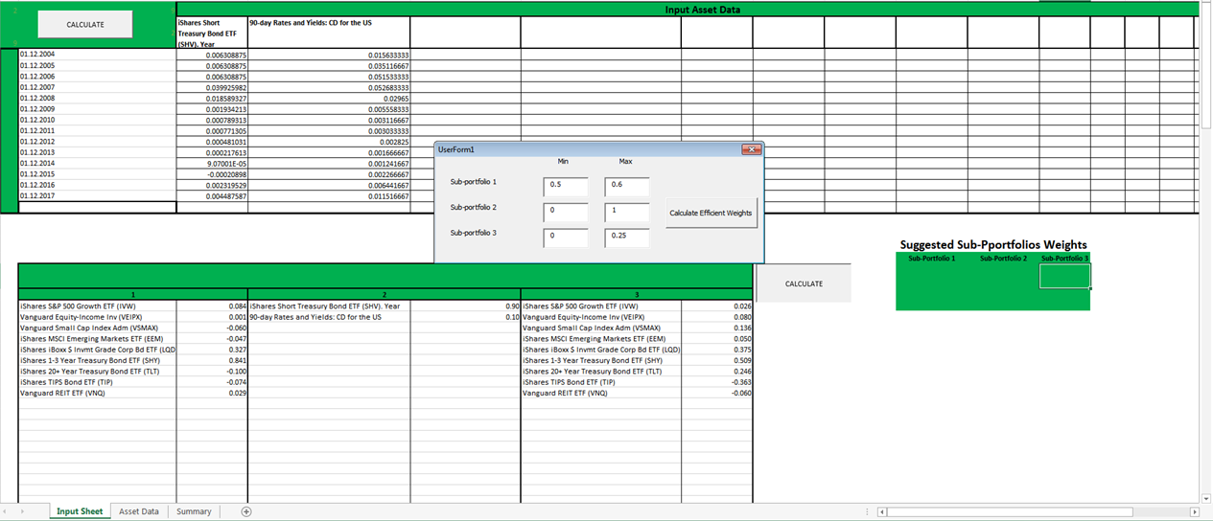

7)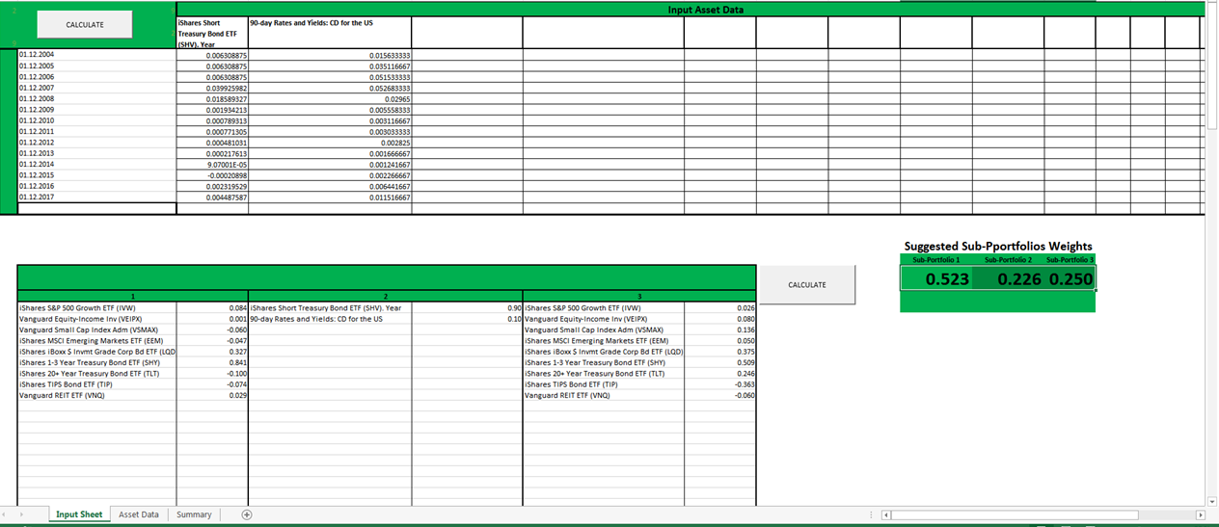

Glossary

MVMA | Mean-Variance Mental Accounting
MA | Mental Account
MA Framework | Mental Accounting Framework
BPT | Behavioral Portfolio Theory
BPT-SA | Behavioral Portfolio Theory Single Account
BPT-MA | Behavioral Portfolio Theory Multiple Accounts
MVO | Mean-Variance Optimization
MVT | Mean-Variance Theory
SP/A | Security-Potential/Aspiration
BLM | Black Litterman model

References
Black, Fischer and Litterman, Robert. Sep/Oct 1992. "Global Portfolio Optimization." Financial Analysts Journal pg. 28.
Hersh Shefrin, Meir Statman. 2000. "Behavioral Portfolio Theory." The Journal of Financial and Quantitative Analysis pp.127-151.
Kahneman D., A. Tversky. 1979. "Prospect Theory: An Analysis of Decision Making under Risk." Econometrica 263-291.
Lopes, L. L., G. C. Oden. 1999. "The Role of Aspiration Level in Risk Choice: A Comparison of Cumulative Prospect Theory and SP/A Theory." Journal of Mathematical Psychology 286-313.
Markowitz, Harry. 1952. "Portfolio Selection." The Journal of Finance pp. 77-91.
Sanjiv Das, Harry Markowitz, Jonathan Scheid , Meir Statman. April 2010 . "Portfolio Optimization with Mental Accounts." The Journal of Financial and Quantitative Analysis pp. 311-334.
William F. Sharpe, Peng Chen, Jerald E. Pinto,Dennis W. McLeavey. n.d. CFA Asset Allocation.

We run all optimizations and mathematical equations using the Visual Basic for Application (VBA) computing package. Mainly Solver and Goal Seek functions have been applied to the portfolio optimization problems.

